Atomica Corp. EOI-
Running Cenfire Version: 1.0



Title: Running Cenfire

Document type:

Document ID: EOI
Author:
Owner:

Approver(s):
Approval date:
Effective date:
Next periodic review date:

Atomica Corp. EOI-
Running Cenfire Version: 1.0

Purpose
The purpose of this document is to provide instructions for running a normal Cenfire production probe on PROBE08, using an already-built recipe. It does not cover creating or editing a recipe - see the Full GUI Manual for that.

Scope

  - This procedure is designed for any personnel running Cenfire wafers who do not need to build or modify the recipe itself.
  - Compliance to a specification is not part of this document.
  - Project specific instructions are not part of this document.

References

  - SOP-17 Manufacturing Processes and Process Control Procedure
  - SOP-15 Control of Records
  - ECP-217 Prober Equipment Control Plan

Deﬁnitions
Table 4: Definitions of terms, acronyms, and abbreviations

Term | Deﬁnition
EMO | Emergency Off. The kill-switch button which should be pressed to cut power to the tool in the event of an emergency.
DMM | Digital Multimeter. Electronic test tool for taking precise measurements of voltage, resistance, current and capacitance.
SMU | Source Measure Unit. Electronic test tool which can source voltage/current while measuring voltage/current.

Responsibilities
  - It is the responsibility of persons operating PROBE08 to read this document.
  - It is the responsibility of the Metrology Engineer to maintain this document.
Atomica Corp. EOI-
Running Cenfire Version: 1.0

Safety

  - The Accretech UF200R contains moving parts. Be careful of motion and pinch points when working with the chuck, head stage and transfer robot.

Figure 6a: Mechanical Hazards
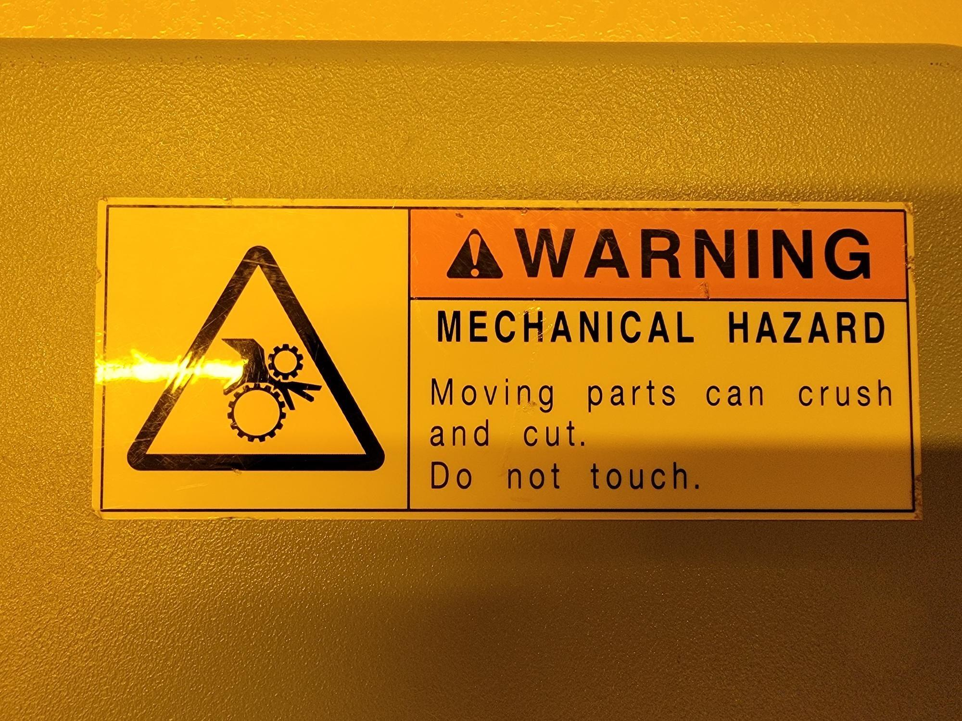
  - In the event of an emergency, press the red EMO button to stop motion and power off the tool.
Figure 6b: Emergency Off
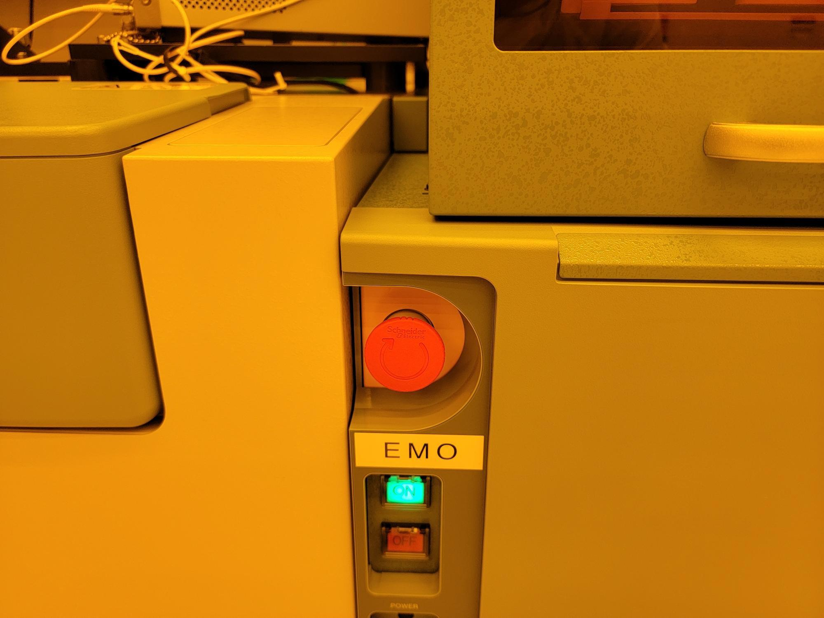
  - The cassette loader uses a Class 1 laser. Never tamper with the cassette loader lock.

Figure 6c: Laser Hazard in Cassette Loader During Operation
Atomica Corp. EOI-
Running Cenfire Version: 1.0

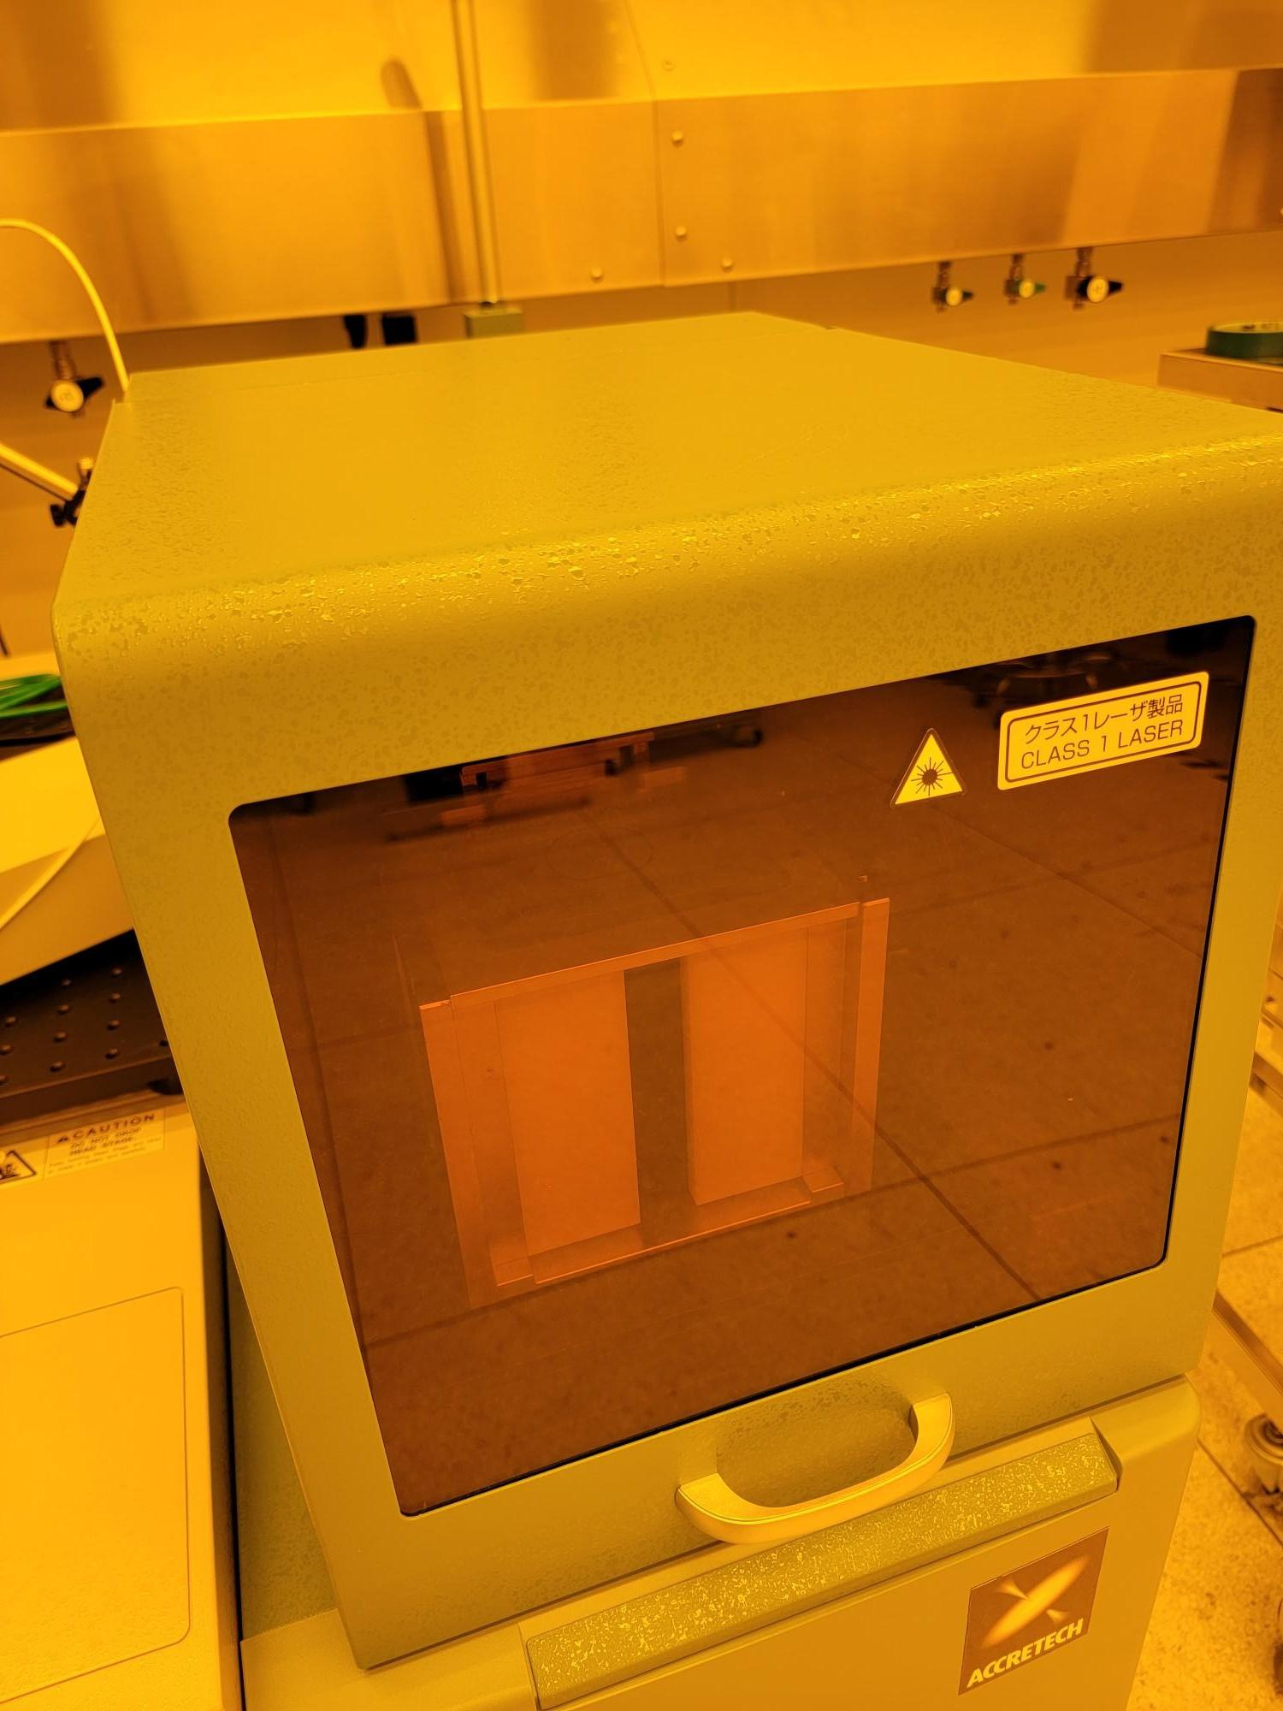

Equipment/Tooling
  - PROBE08 Accretech UF200R Fully Automatic Prober
  - KEYSIGHT 34461A Digital Multimeter
  - KEITHLEY 2636B Source Meter
  - KEYSIGHT 33500B Waveform Generator
  - Cenfire program-specific probe card (COSETTE)

Procedure

Setup
    - Verify Accretech UF200R is powered on without warnings (Figure 8a).

Figure 8a: PROBE08 Powered ON
Atomica Corp. EOI-
Running Cenfire Version: 1.0

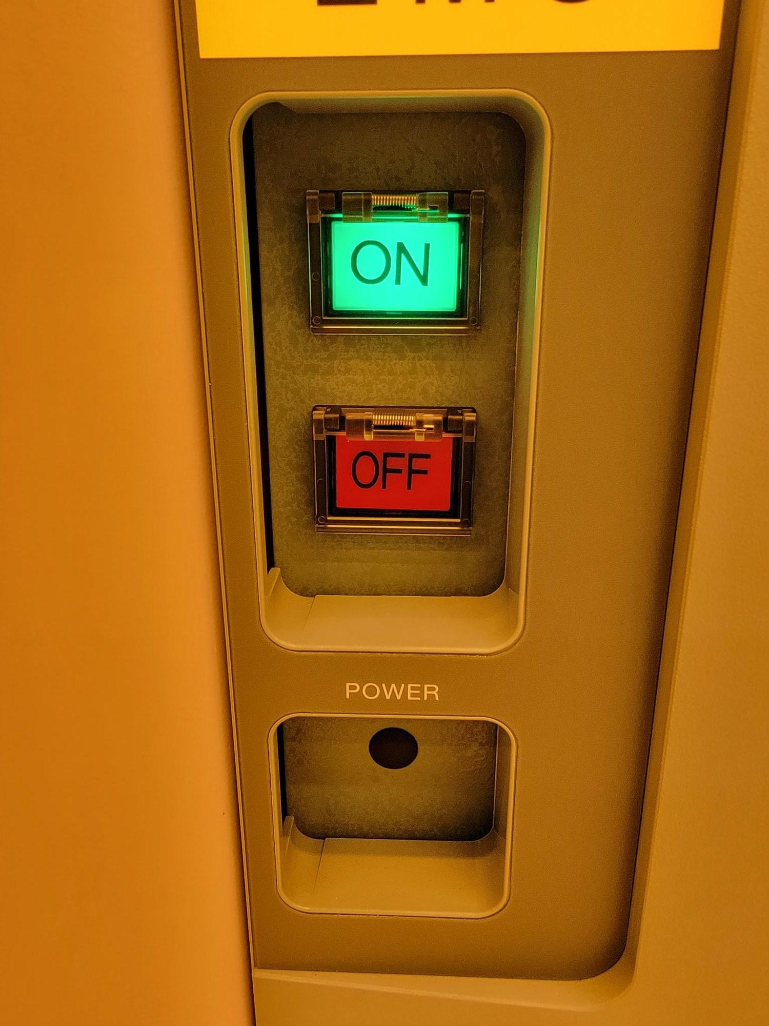
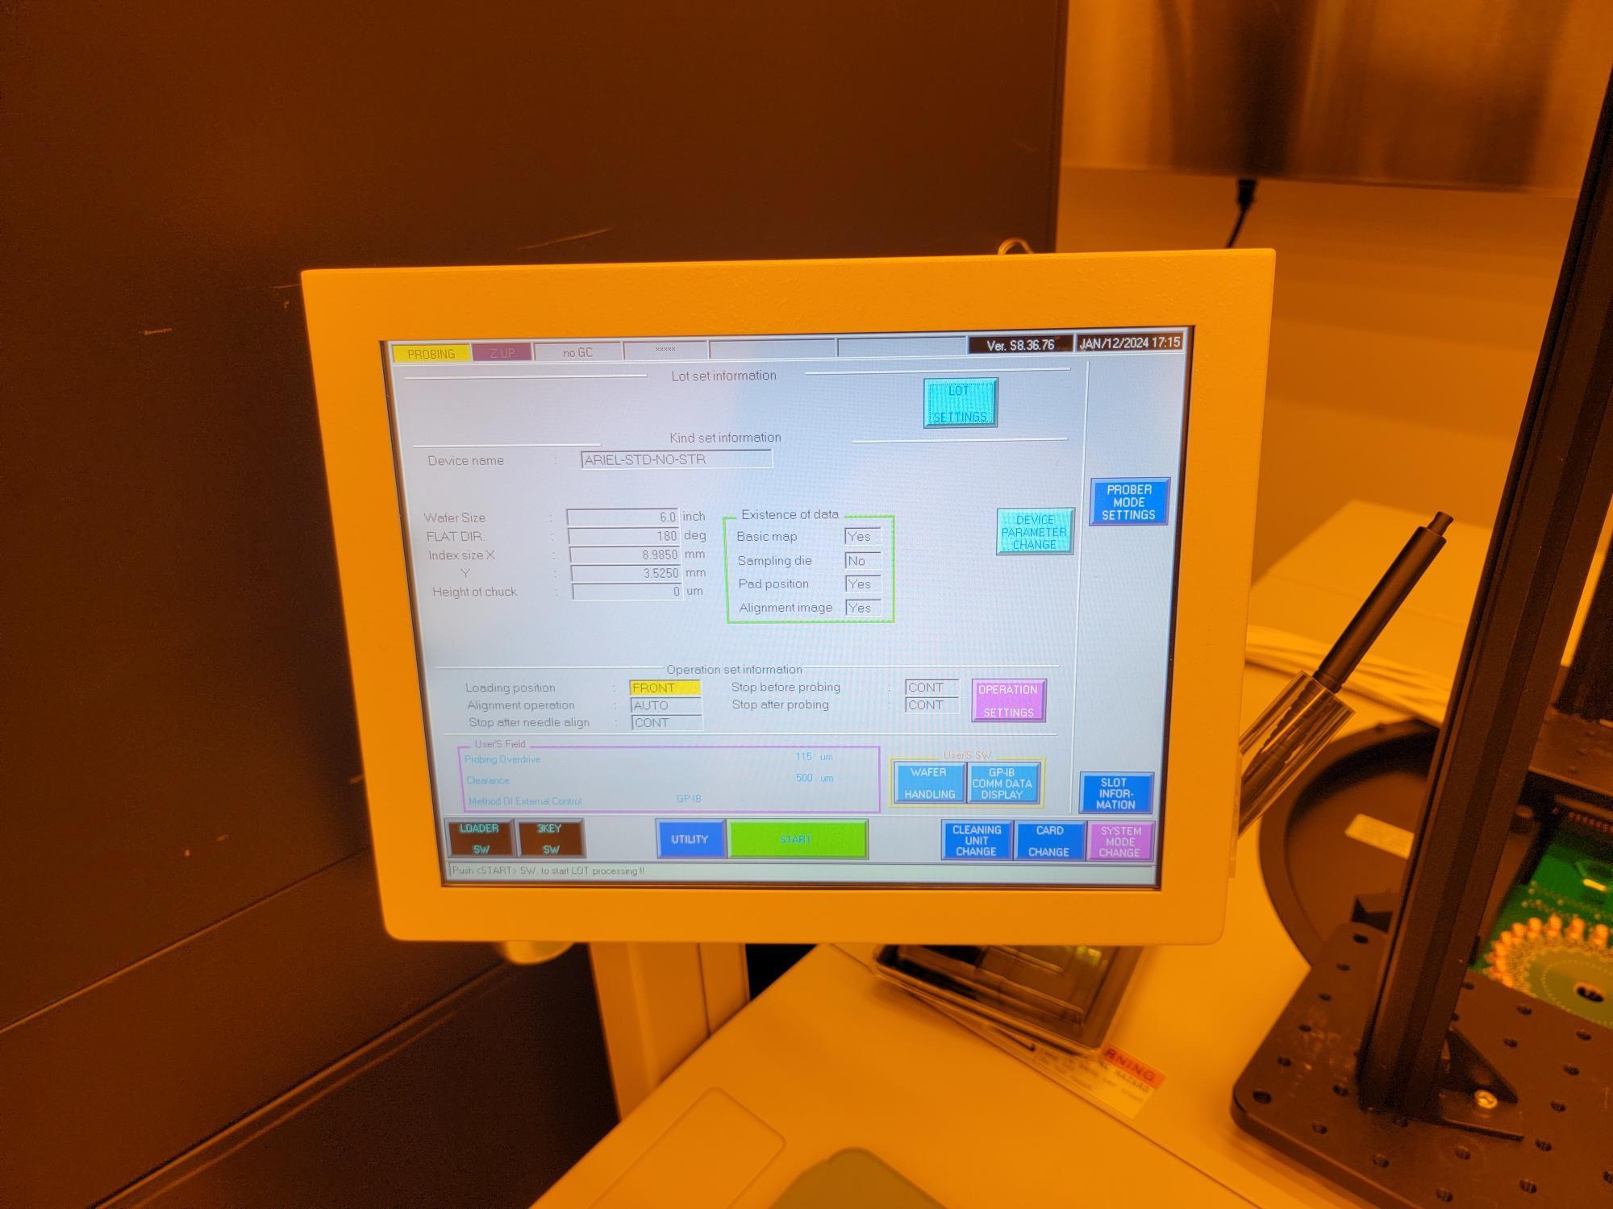

    - Verify KEYSIGHT 34461A is powered on (Figure 8b).

Figure 8b: KEYSIGHT 34461A DMM Powered ON
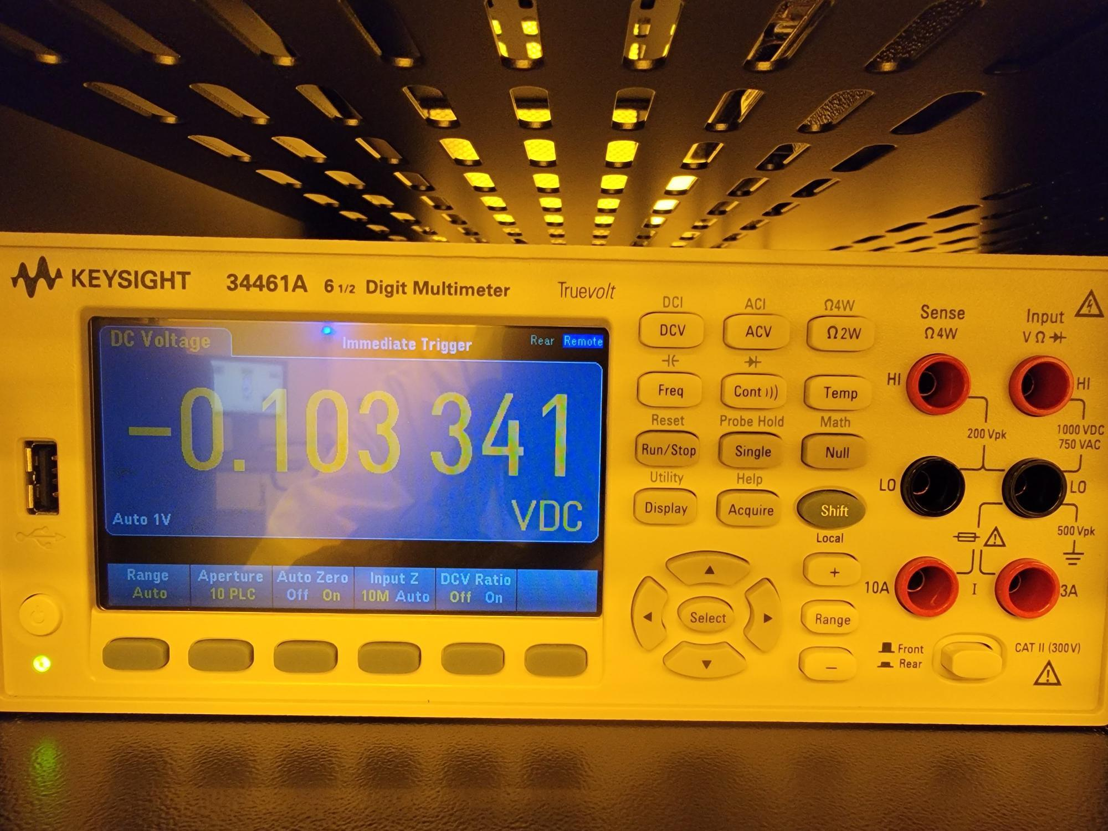
Atomica Corp. EOI-
Running Cenfire Version: 1.0

    - Verify KEITHLEY 2636B is powered on (Figure 8c).

Figure 8c: KEITHLEY 2636B SMU Powered ON
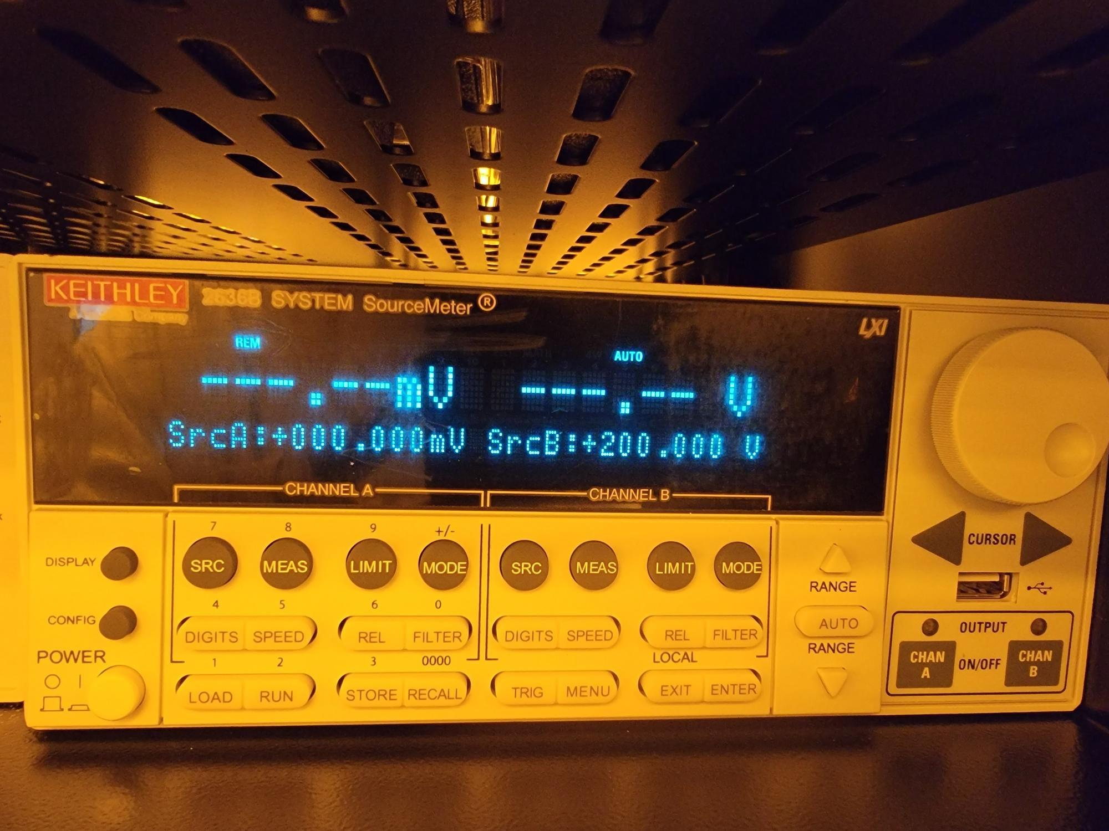
    - Verify KEYSIGHT 33500B is powered on (Figure 8d).
Figure 8d: KEYSIGHT 33500B Function Generator Powered ON
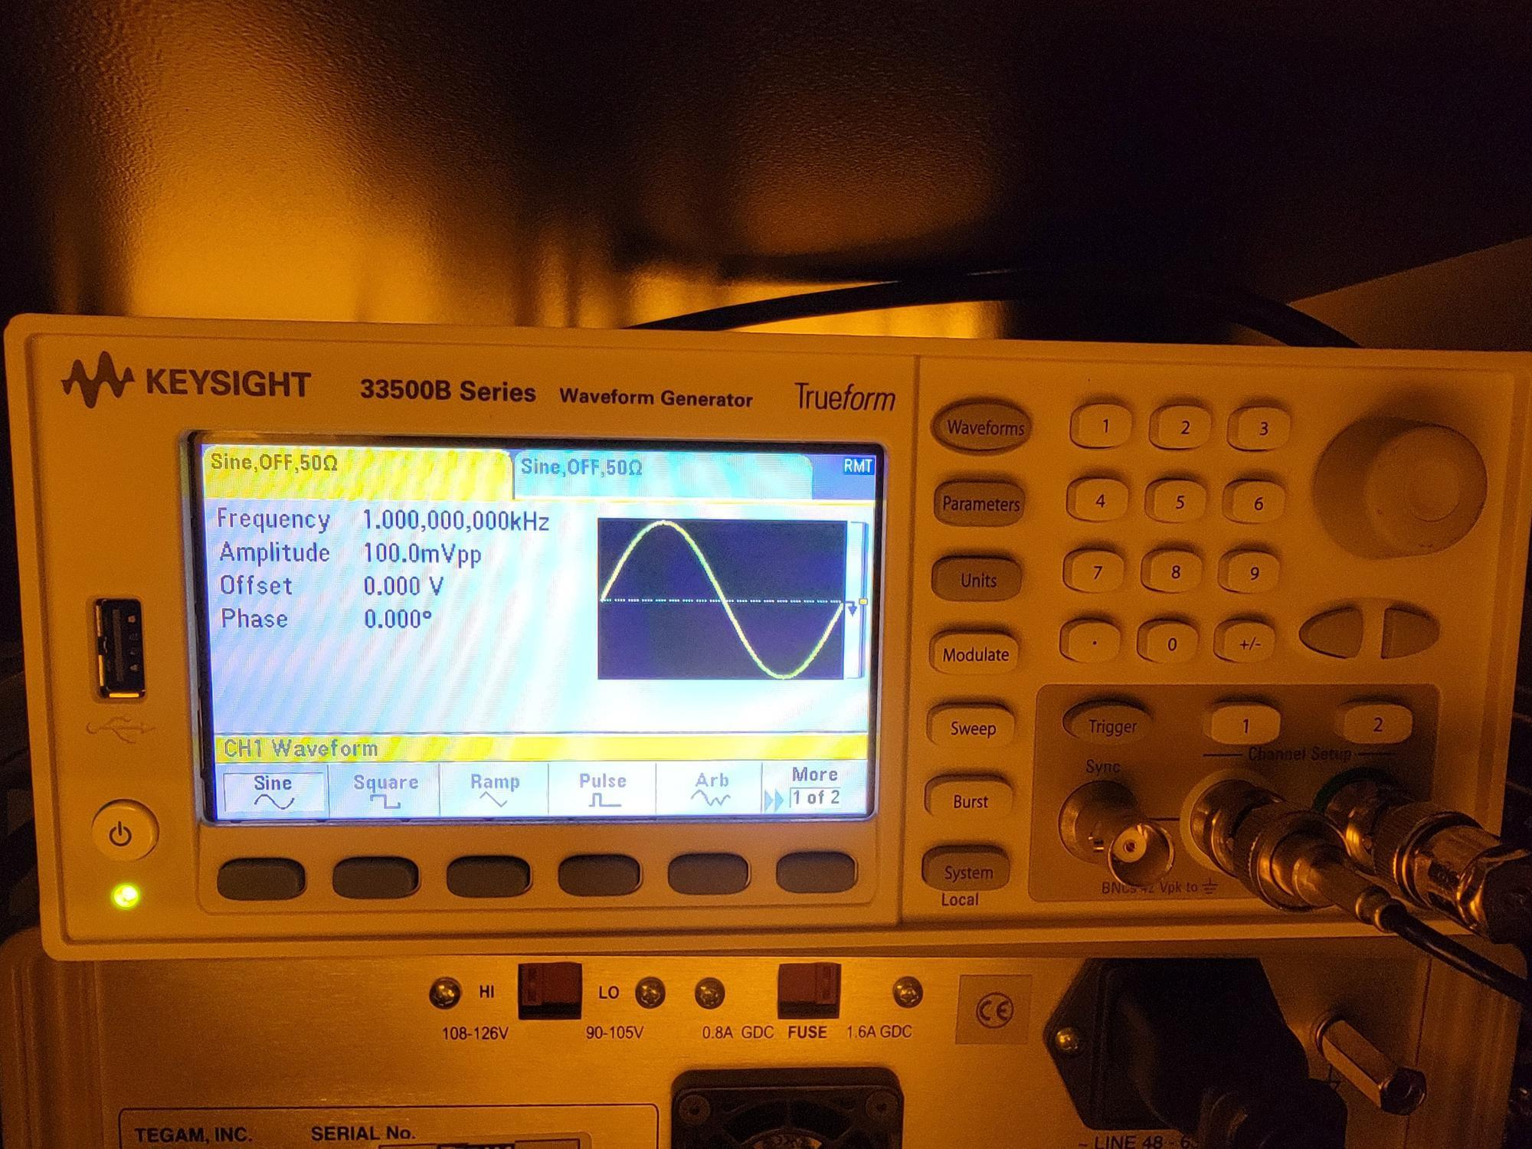
    - You can also check all instruments by opening the GUI and verifying the green checkmarks on the left.
Figure 8e: Instrument Connections
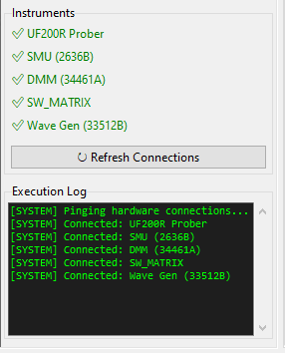

Changing Probe Card
    - Within the main production screen, press “CARD CHANGE” (Figure 8e).

Figure 8e: CARD CHANGE
Atomica Corp. EOI-
Running Cenfire Version: 1.0

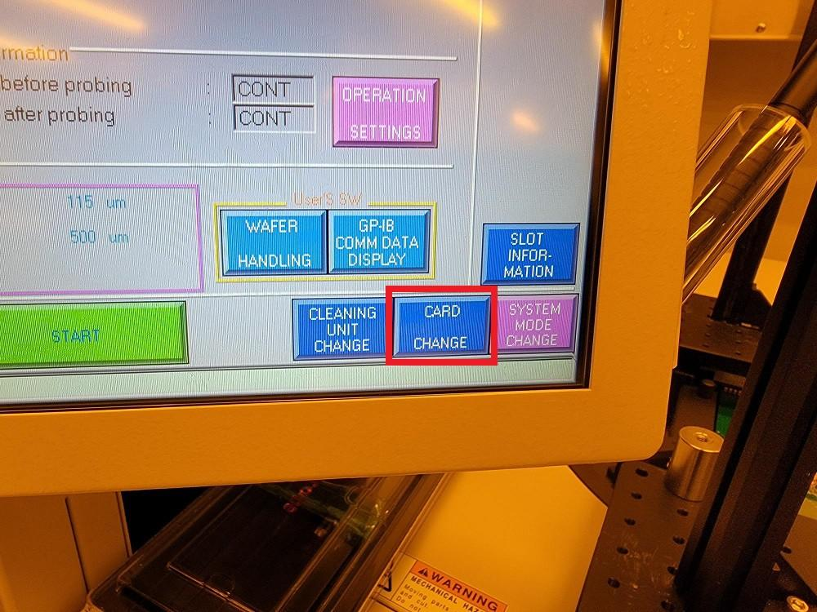
    - Press “CARD CHANGE START” (Figure 8f).

Figure 8f: CARD CHANGE START
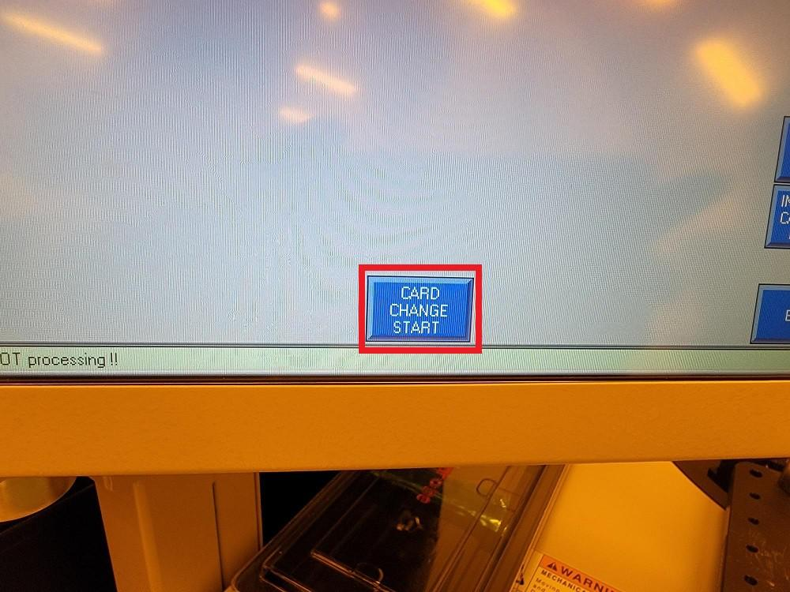
    - Loosen (4) thumb screws and open clamps (Figure 8g).

Figure 8g: Loosen Screws and Open Clamps
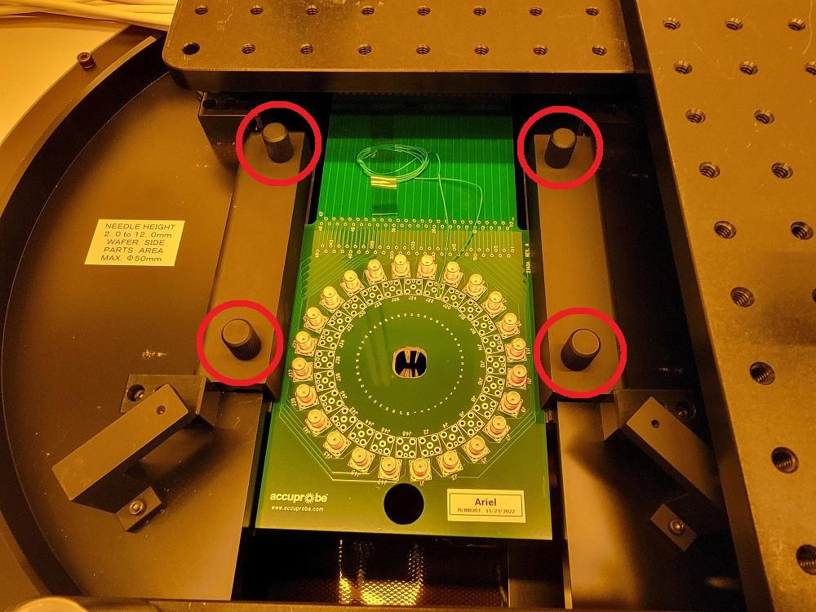
Atomica Corp. EOI-
Running Cenfire Version: 1.0

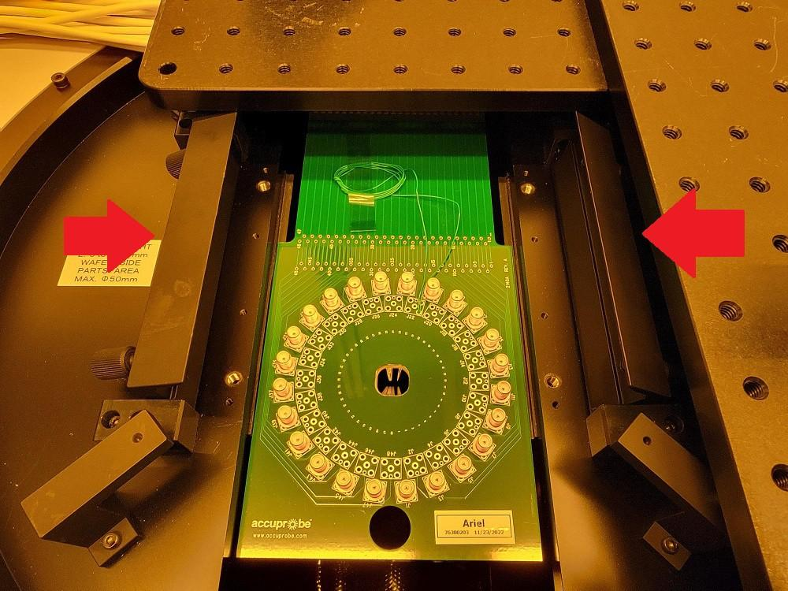
    - Use the hole at the front edge of the probe card to carefully pull the probe card out of the connector socket and remove the probe card (Figure 8h).

WARNING: Be very careful to avoid damaging the probe needles on the bottom of the probe card.

Figure 8h: Slide Probe Card Out of Edge Connector Socket
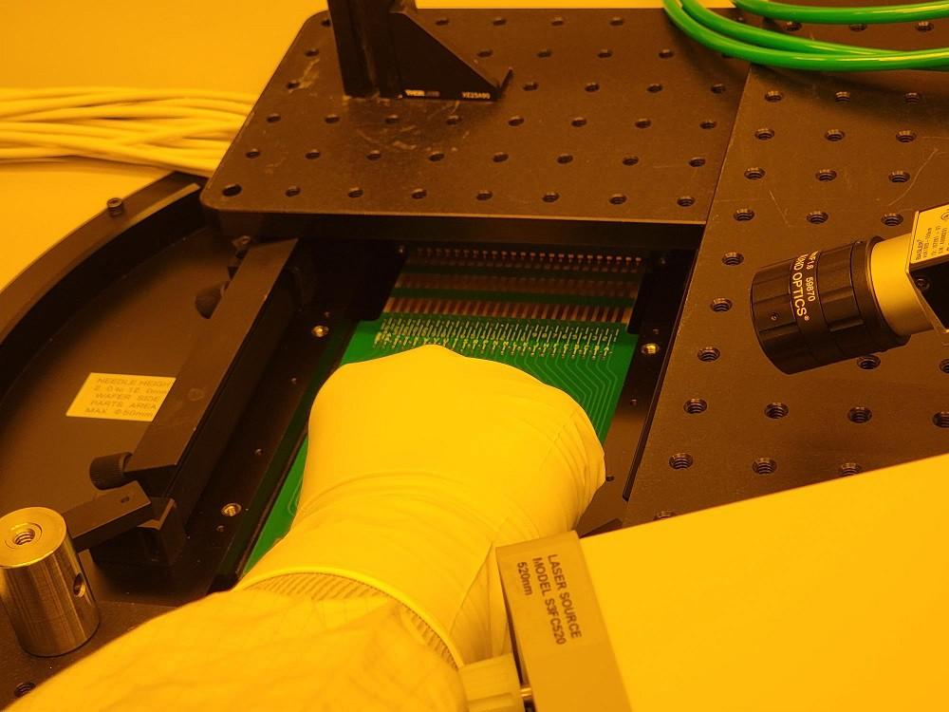
    - On the bottom of the probe card, carefully place the plastic probe needle cover over the probe needles and make sure it is secured with tape (Figure 8i).

Figure 8i: Probe Needle Cover Centered Over Probe Needles
Atomica Corp. EOI-
Running Cenfire Version: 1.0

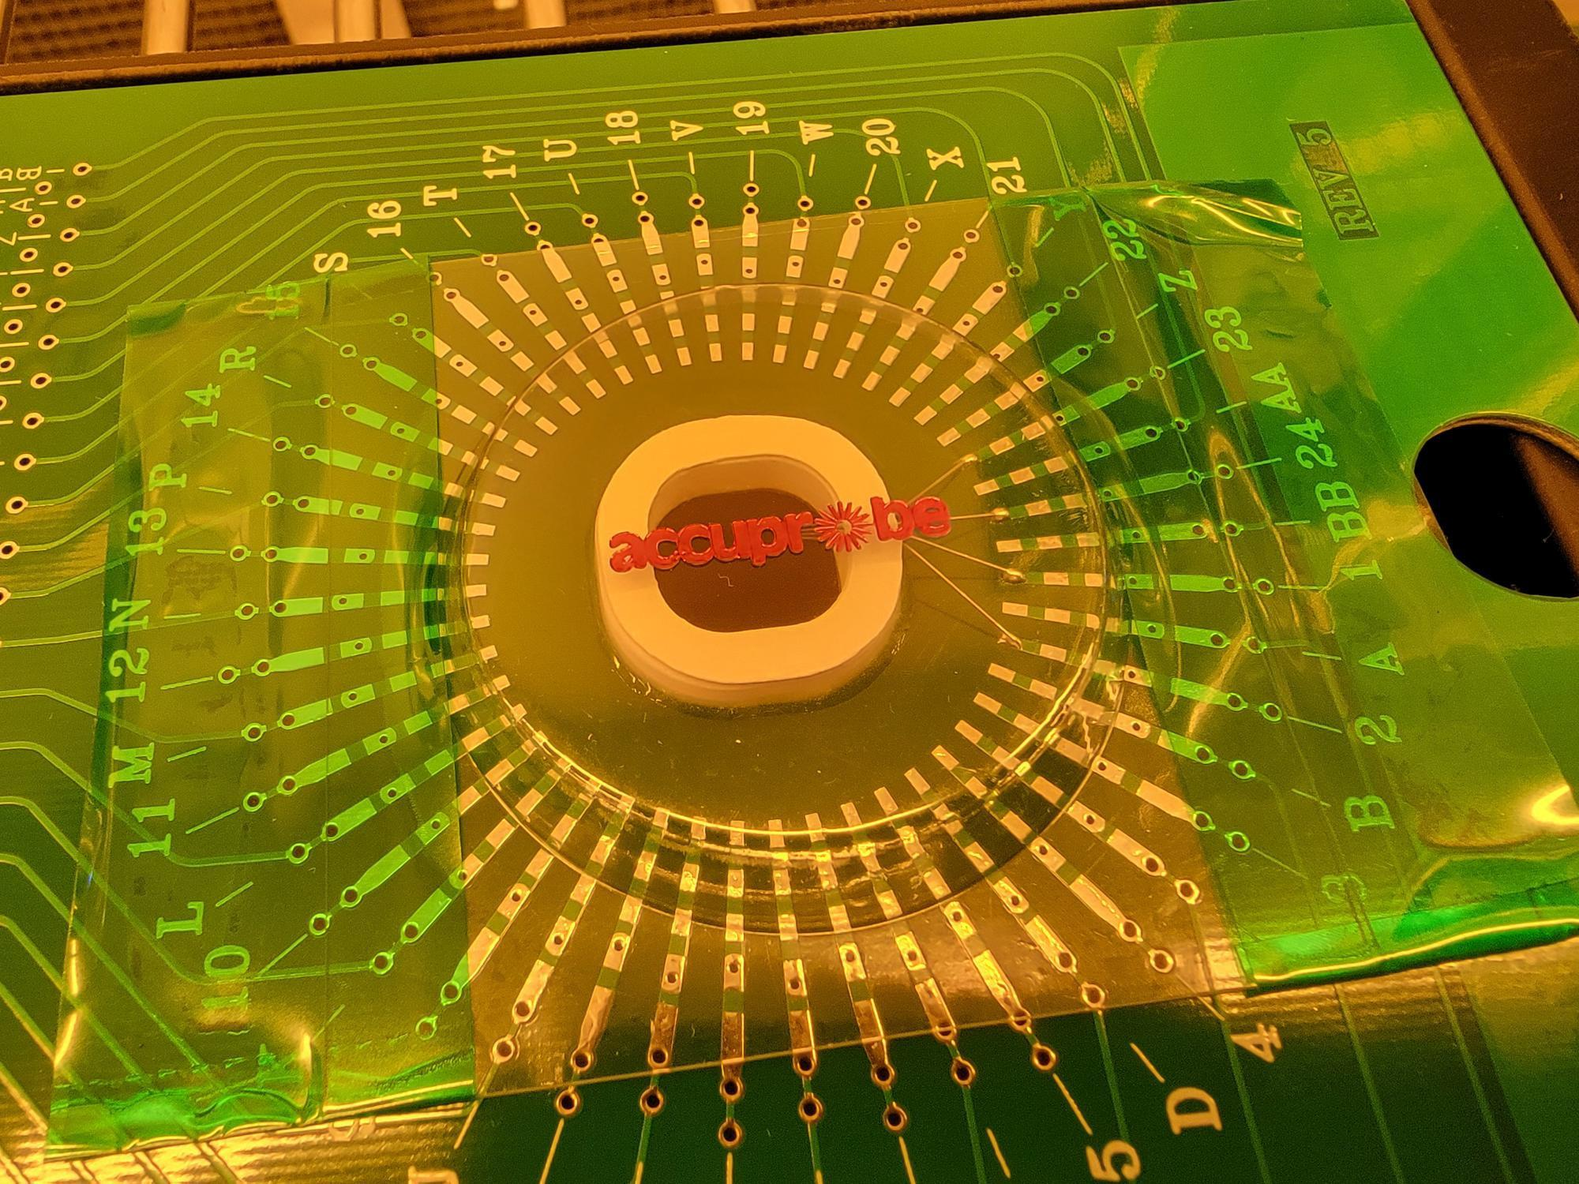
    - Store the old probe card in its case from Accuprobe on the PROBE08 rack (Figure 8j).

Figure 8j: Store Probe Cards on PROBE08 Rack
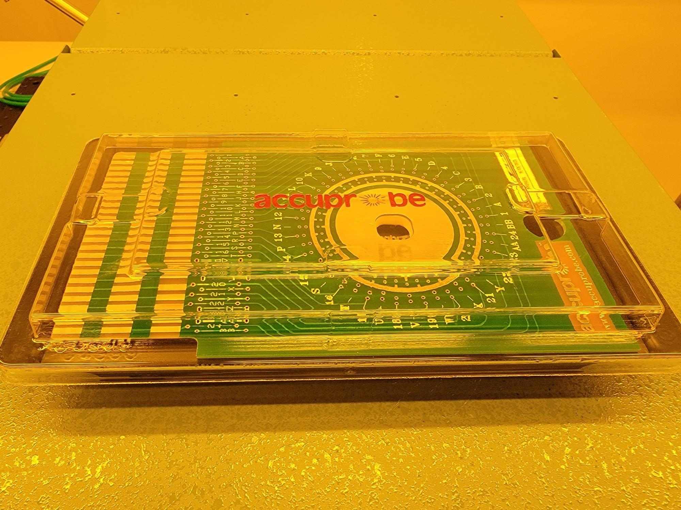
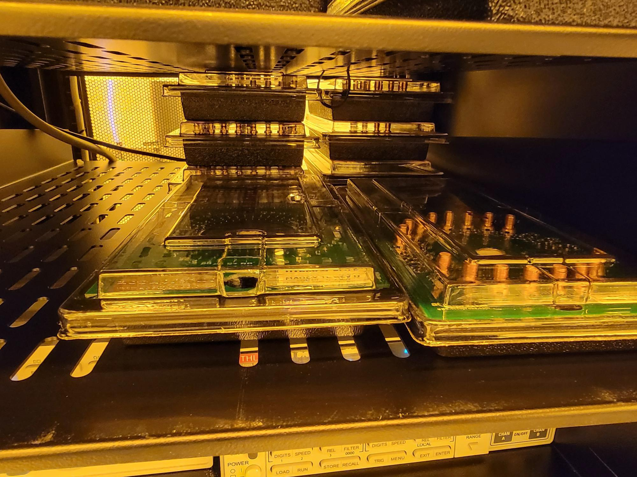

    - Carefully remove the plastic probe needle cover from the new probe card and mount it onto the stage rails so that the probe needles are pointing down. Once the new probe card is flat and centered on the rails, use the hole at the front edge of the probe card to push the probe edge connector into the socket (Figure 8k).

Figure 8k: Use Rails to Guide Probe Card Into Edge Connector Socket
Atomica Corp. EOI-
Running Cenfire Version: 1.0

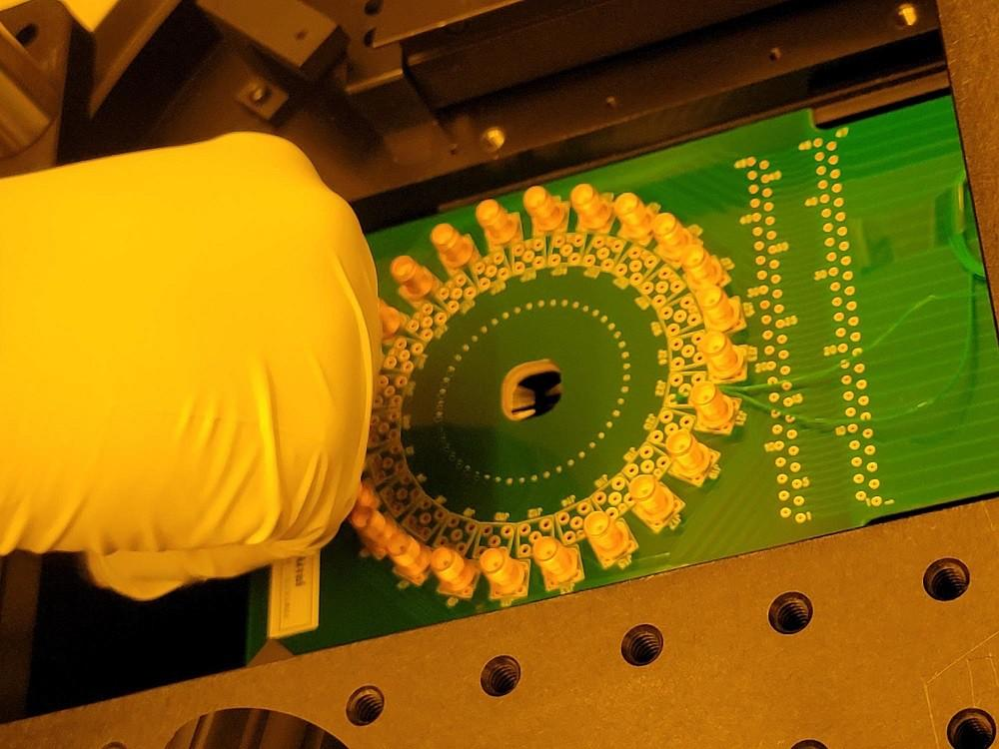
    - Bring the clamps down and tighten (4) thumb screws (Figure 8l).

Figure 8l: New Probe Card Installed
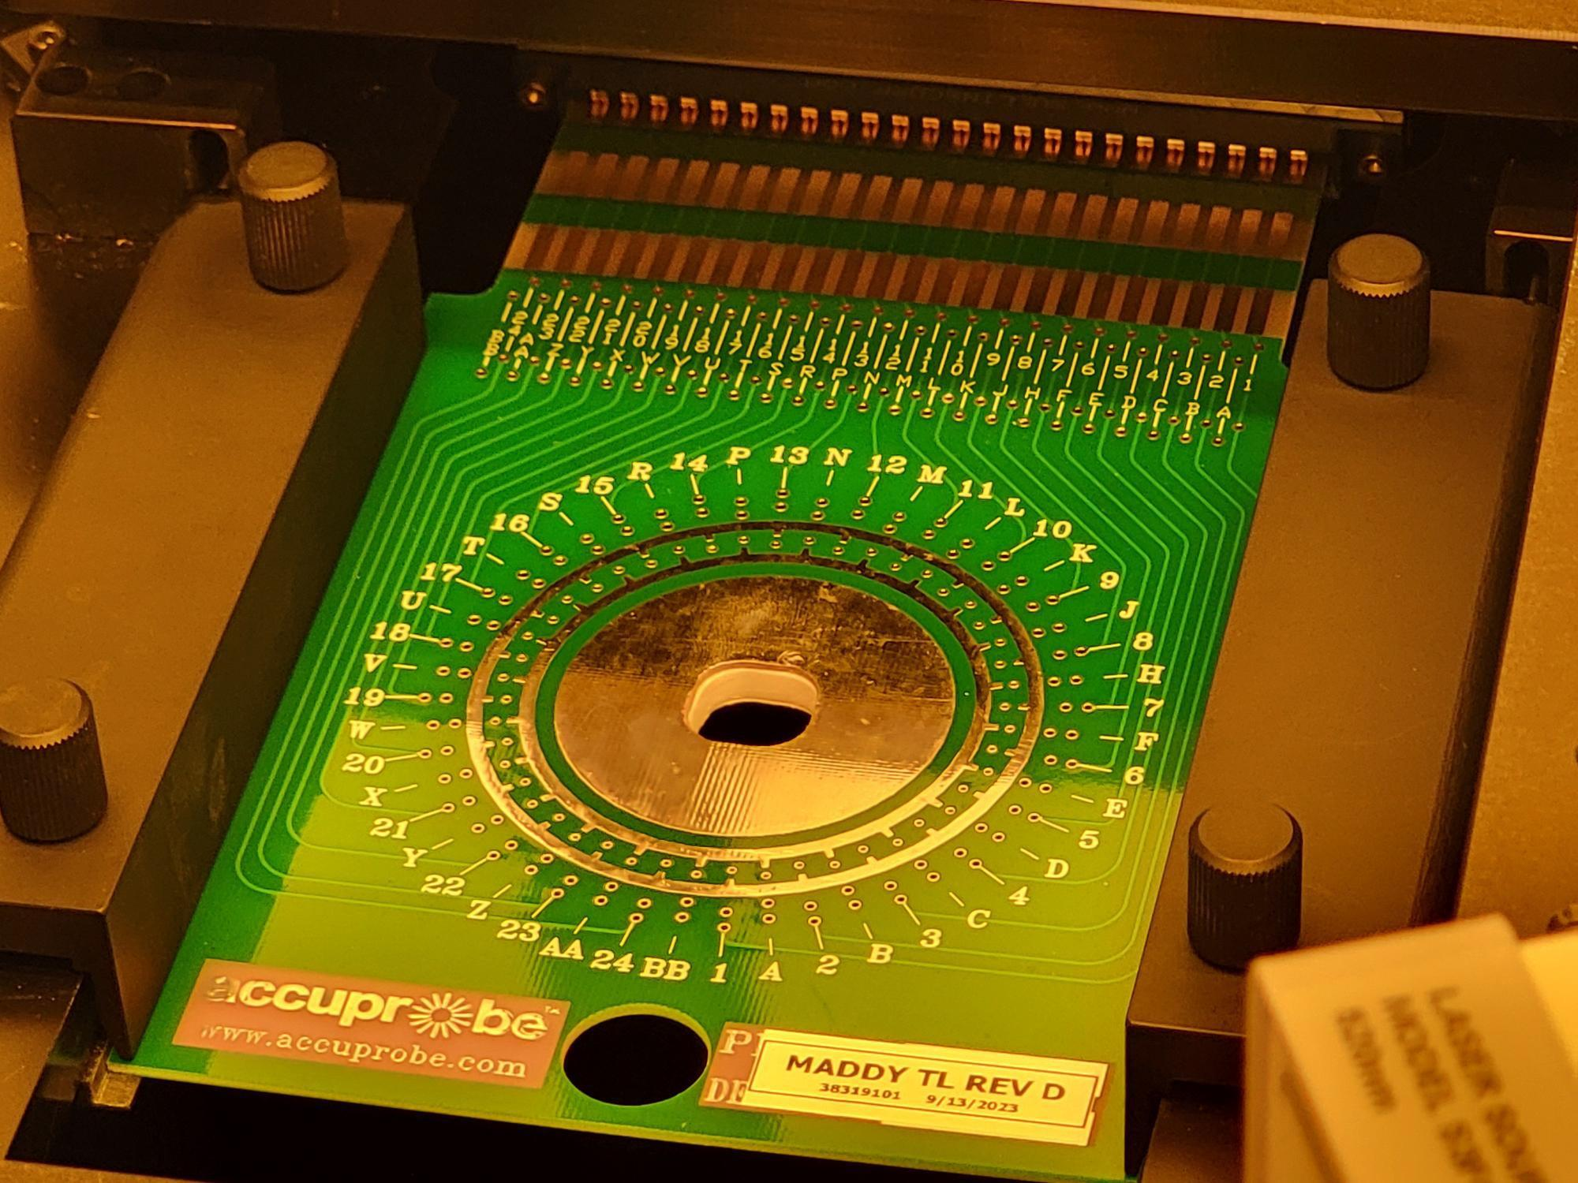
    - Press “CARD CHANGE END” (Figure 8m).

Figure 8m: CARD CHANGE END
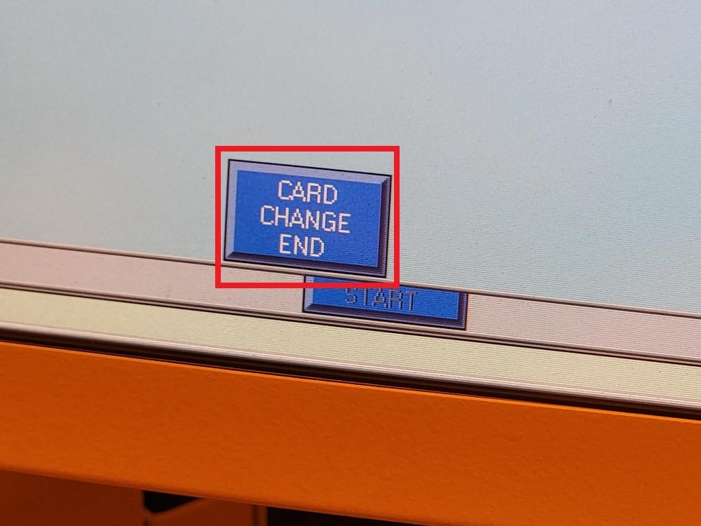
    - Press “END” (Figure 8n).

Figure 8n: END in Manual Card Change Prompt
Atomica Corp. EOI-
Running Cenfire Version: 1.0

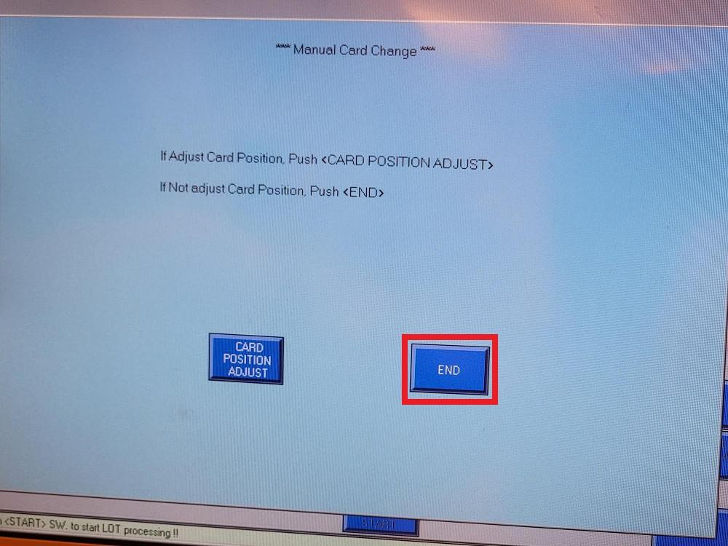
    - Press “END” (Figure 8o) to complete the probe card change and return to the main production screen.

Figure 8o: END to Complete Card Change
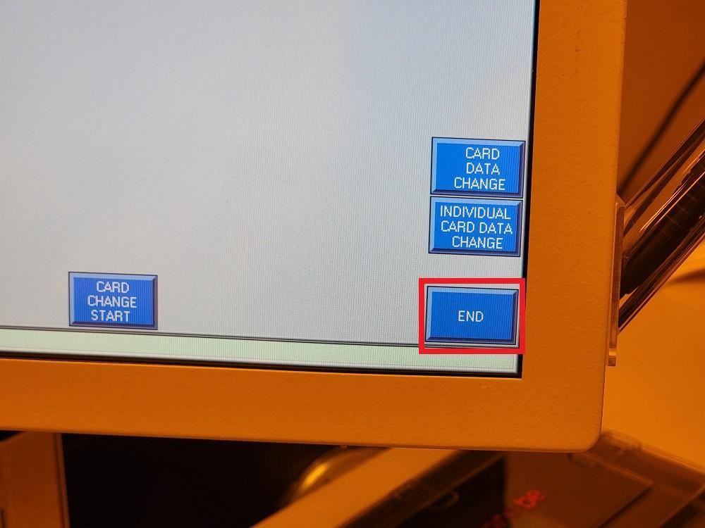
    - Next, the correct recipe for the new probe card must be loaded. Press “DEVICE PARAMETER CHANGE” (Figure 8p).

Figure 8p: DEVICE PARAMETER CHANGE
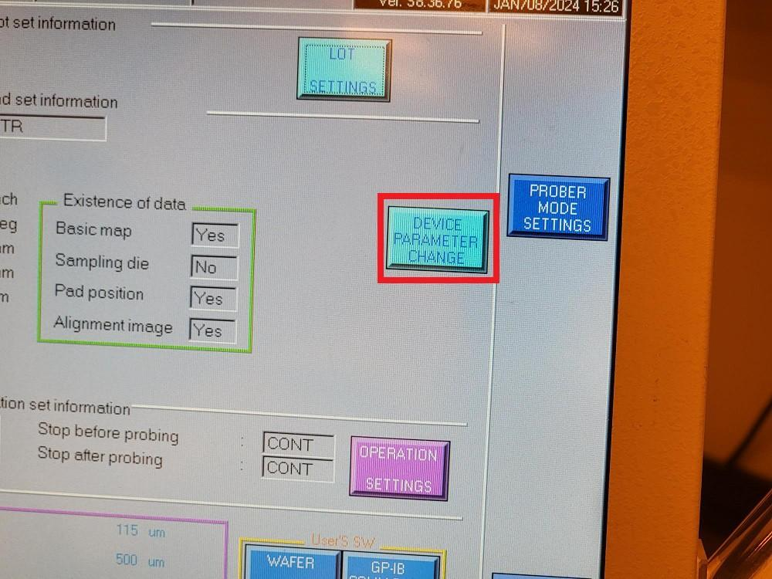
    - Press “DEVICE LIST REFERENCE” (Figure 8q).
Atomica Corp. EOI-
Running Cenfire Version: 1.0

Figure 8q: DEVICE LIST REFERENCE
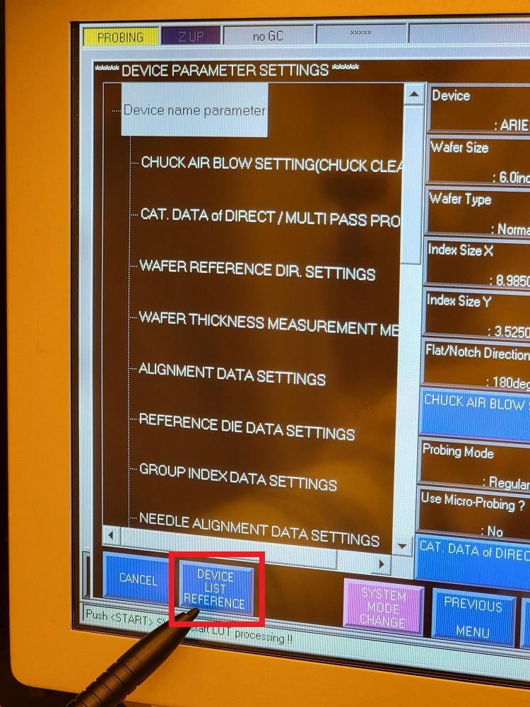
    - Verify “HD” is highlighted and press “EXECUTE” (Figure 8r).

Figure 8r: EXECUTE
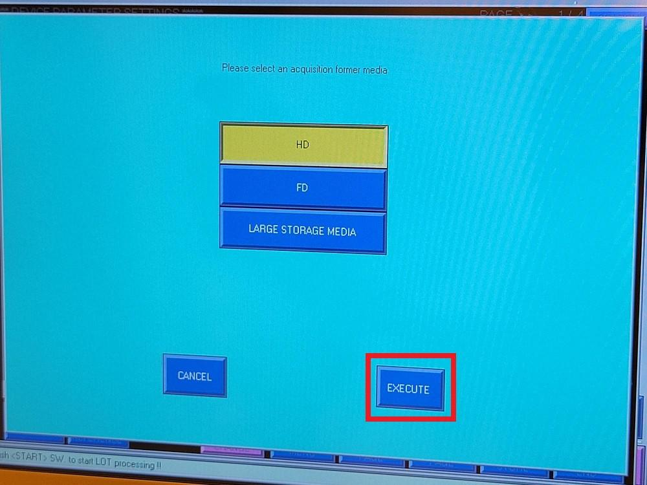
    - Select the correct recipe for the new probe card (Figure 8s).

NOTE: The recipe to use will be specified by the project team, MES or traveler.

Figure 8s: Highlight the Intended Recipe in the Device List
Atomica Corp. EOI-
Running Cenfire Version: 1.0

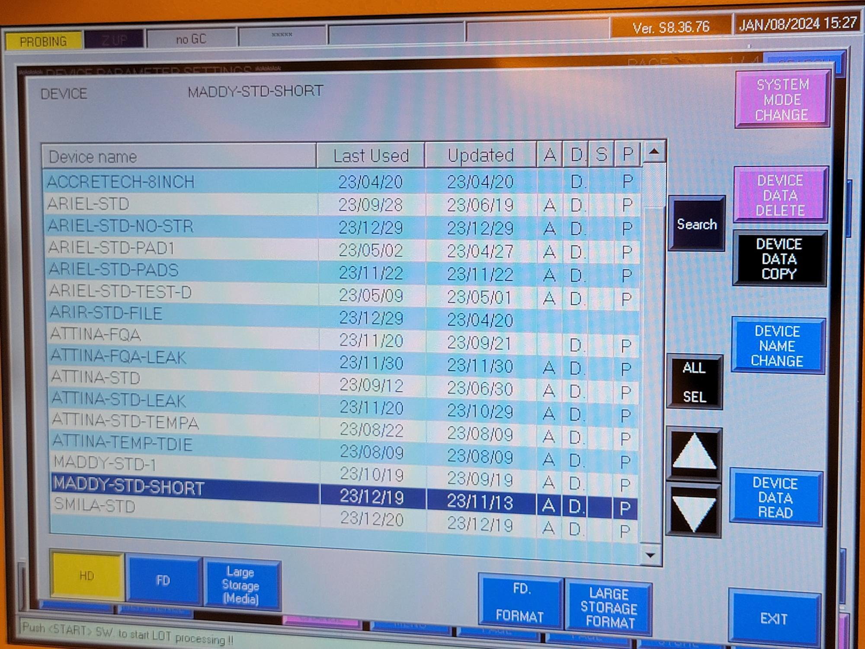
    - Press “DEVICE DATA READ” (Figure 8t).

Figure 8t: DEVICE DATA READ
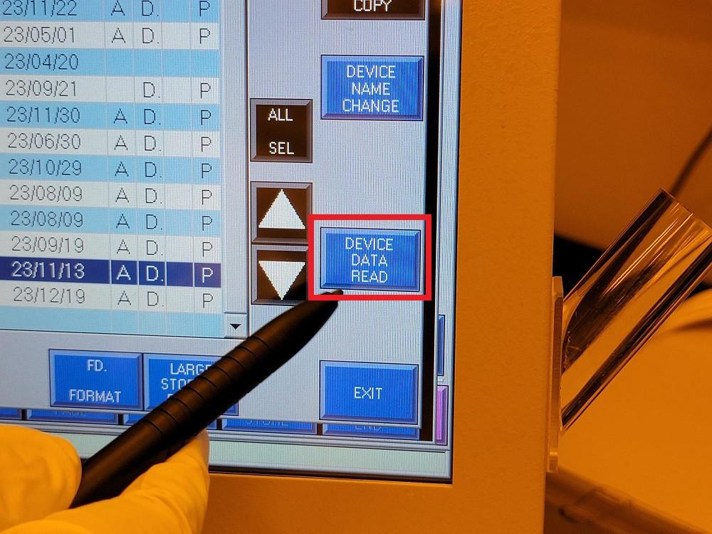
    - When prompted, press “EXECUTE” (Figure 8u).

Figure 8u: EXECUTE
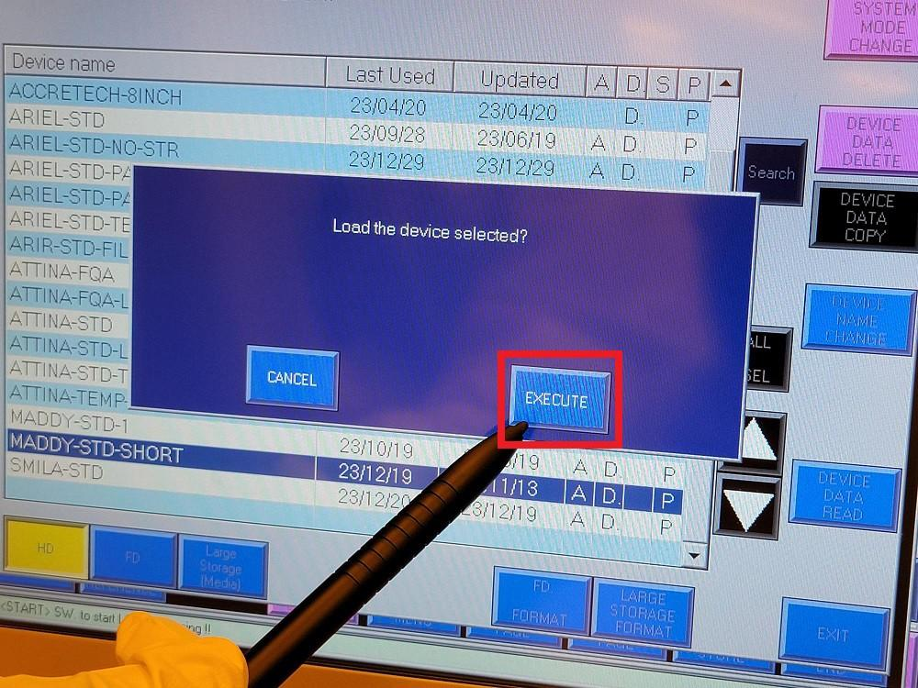
    - Press “SETTING END” (Figure 8v) to return to the main production screen.

Figure 8v: SETTING END
Atomica Corp. EOI-
Running Cenfire Version: 1.0

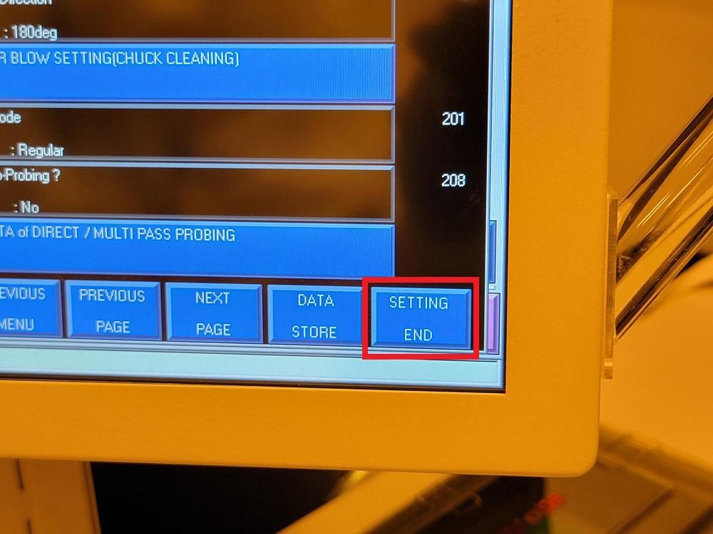

Starting Probe Routine
    - Press “OPERATION SETTINGS” (Figure 8w).

Figure 8w: OPERATION SETTINGS
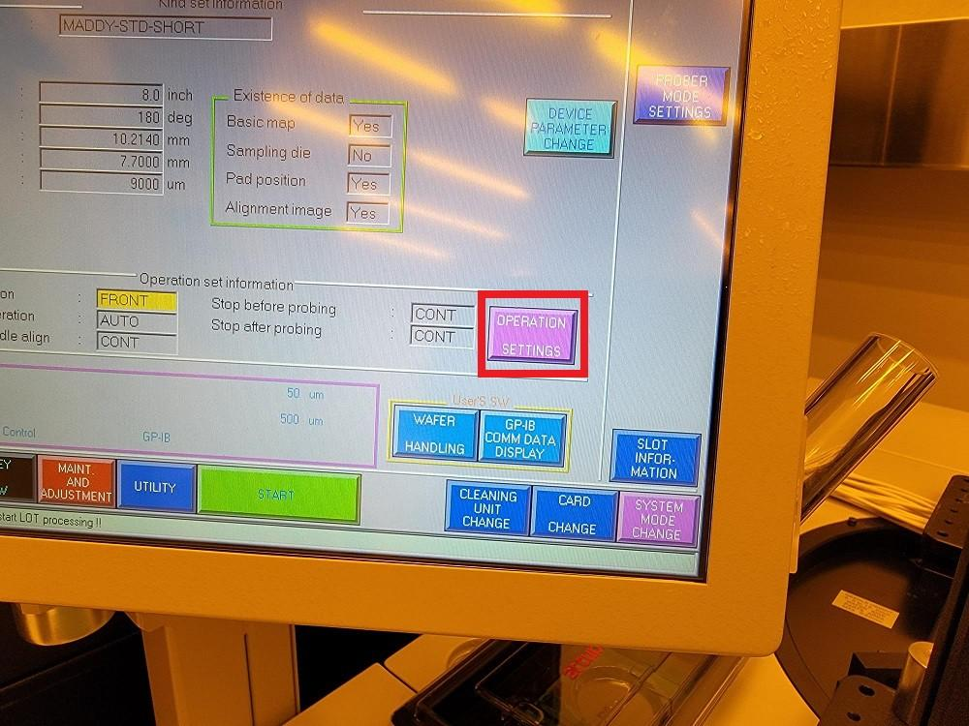
    - Verify the correct Loading/Unloading position is highlighted and press “ENT” (Figure 8x).

NOTE: The Loading/Unloading position will be program specific. 8" programs must use FRONT ACCESS DOOR and 6" programs generally use CASSETTE, although 6" wafers can be loaded using FRONT ACCESS DOOR as well. For directions on loading and unloading wafers using CASSETTE, refer to section 8.4 below.

Figure 8x: Loading/Unloading Positions
Atomica Corp. EOI-
Running Cenfire Version: 1.0

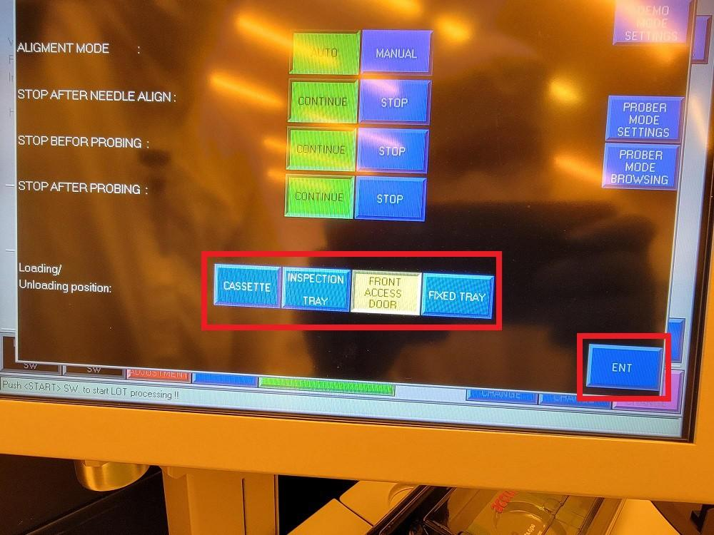
    - Press “START” (Figure 8y).

Figure 8y: START
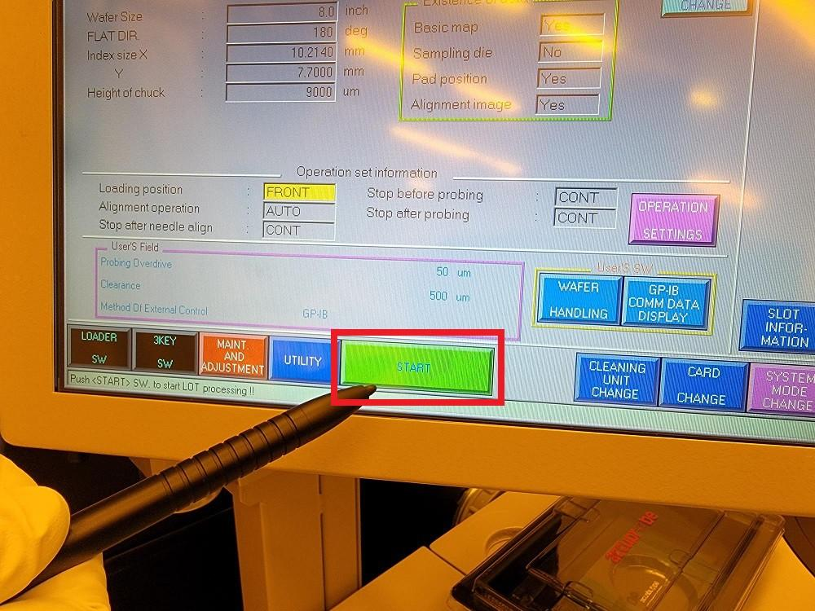
    - Press “Clear screen” when prompted with “Put wafer on CHUCK !!” (Figure 8z).

Figure 8z: Clear Screen
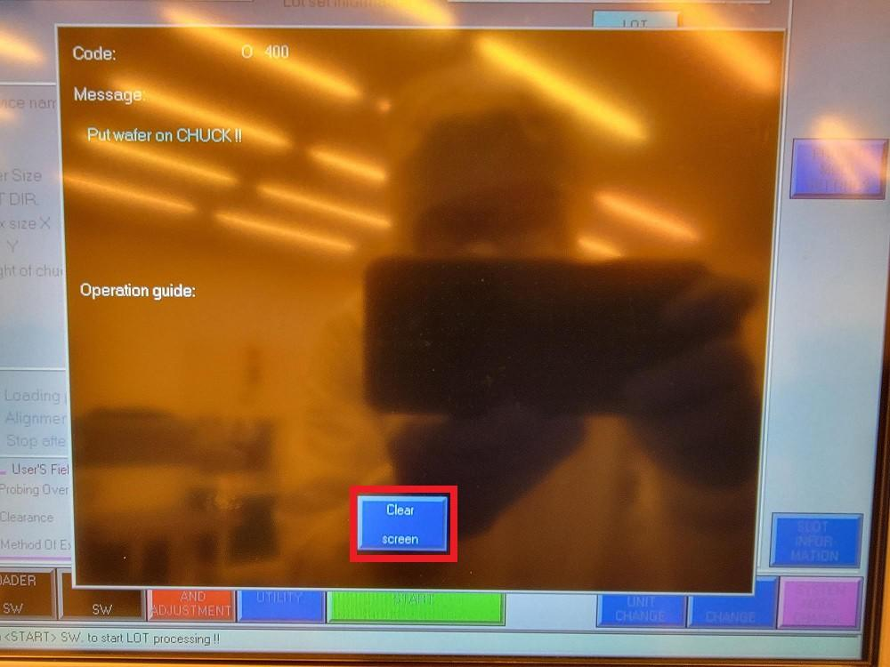
    - Open the Front Access Door (Figure 8aa).

Figure 8aa: Opening Front Access Door
Atomica Corp. EOI-
Running Cenfire Version: 1.0

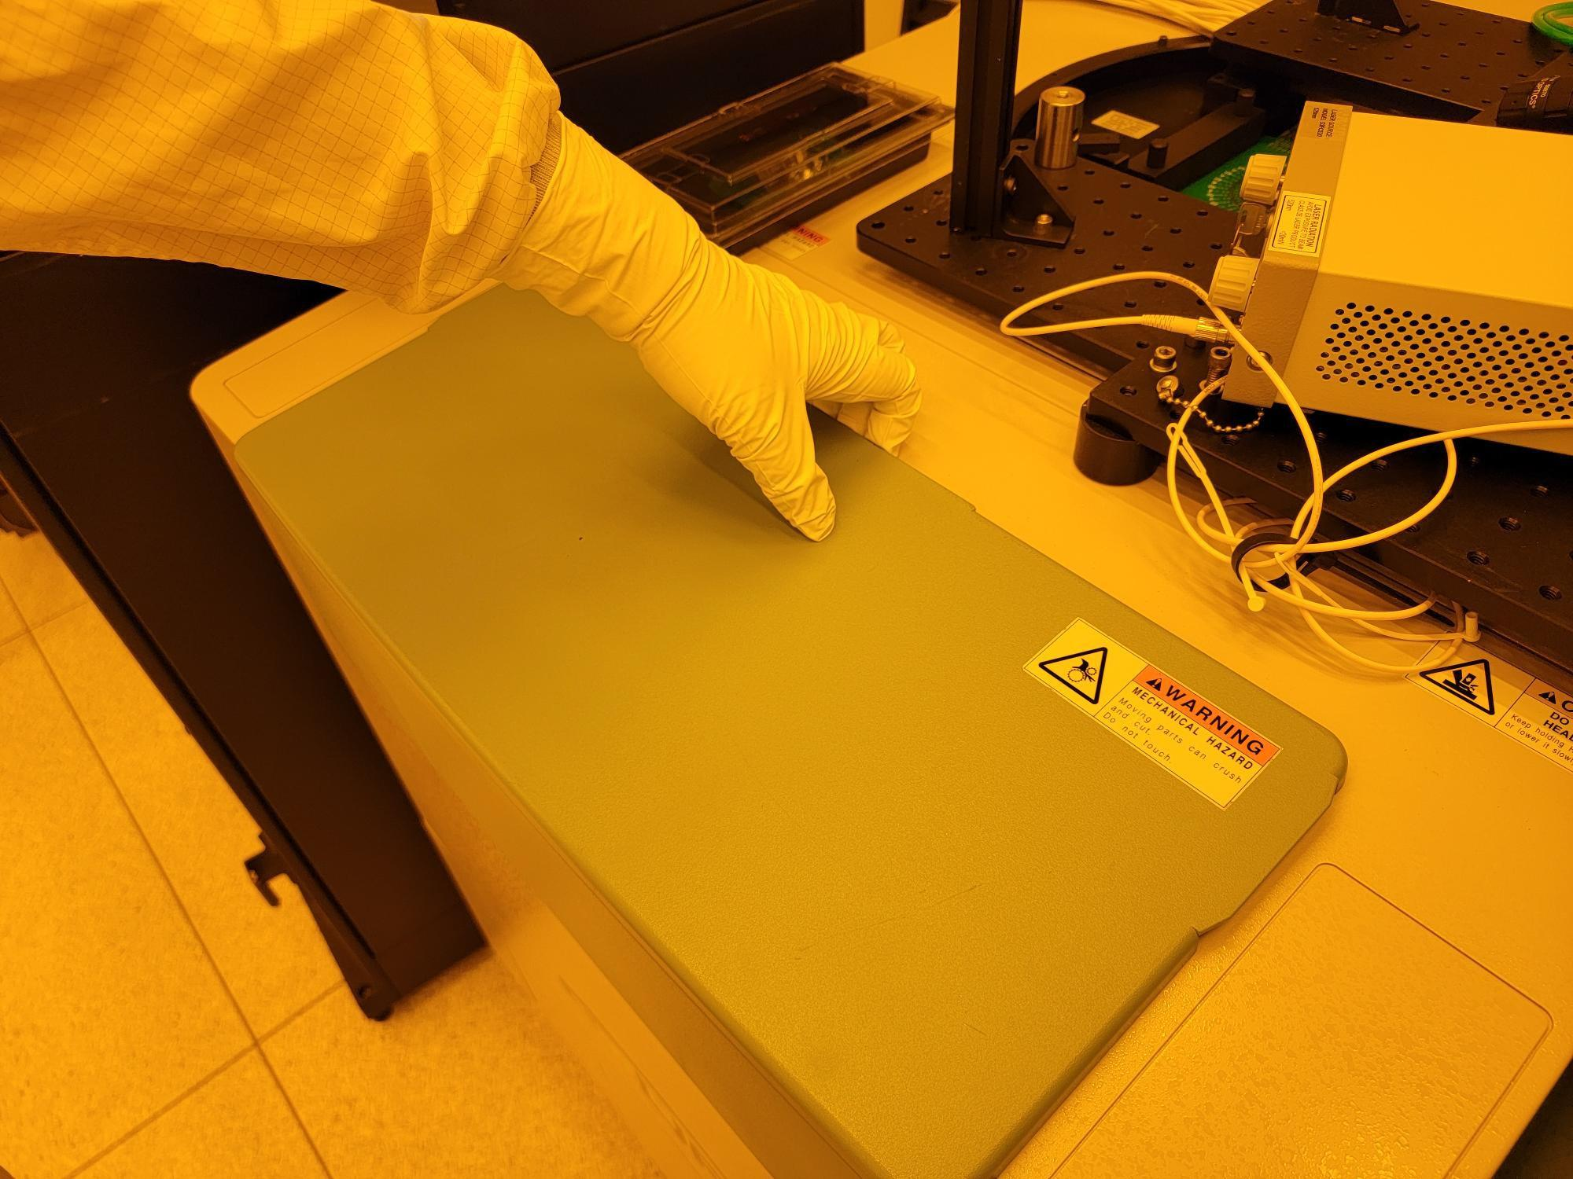
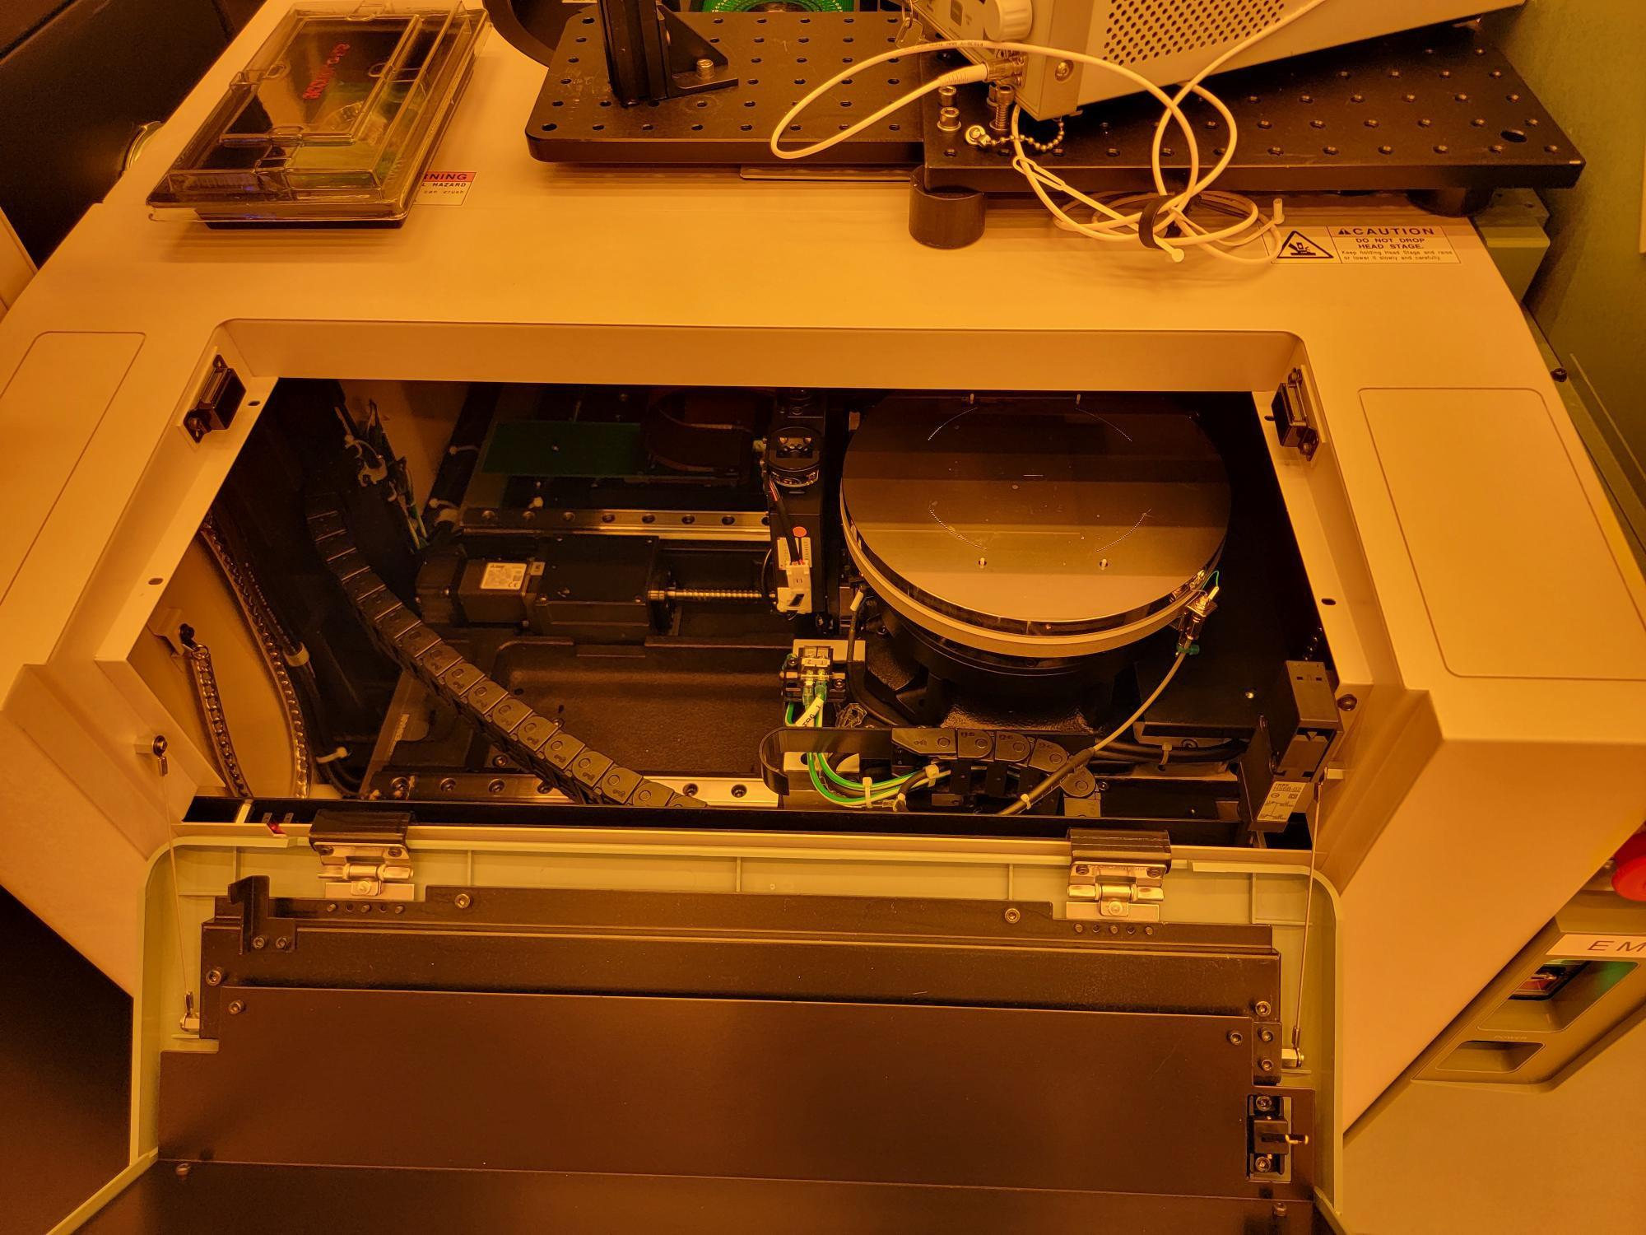

    - Load the wafer on top of the chuck pins so that the notch is aligned with the hole at 6 o'clock (Figure 8ab).

Figure 8ab: Notch Aligned with Hole at 6 O'clock
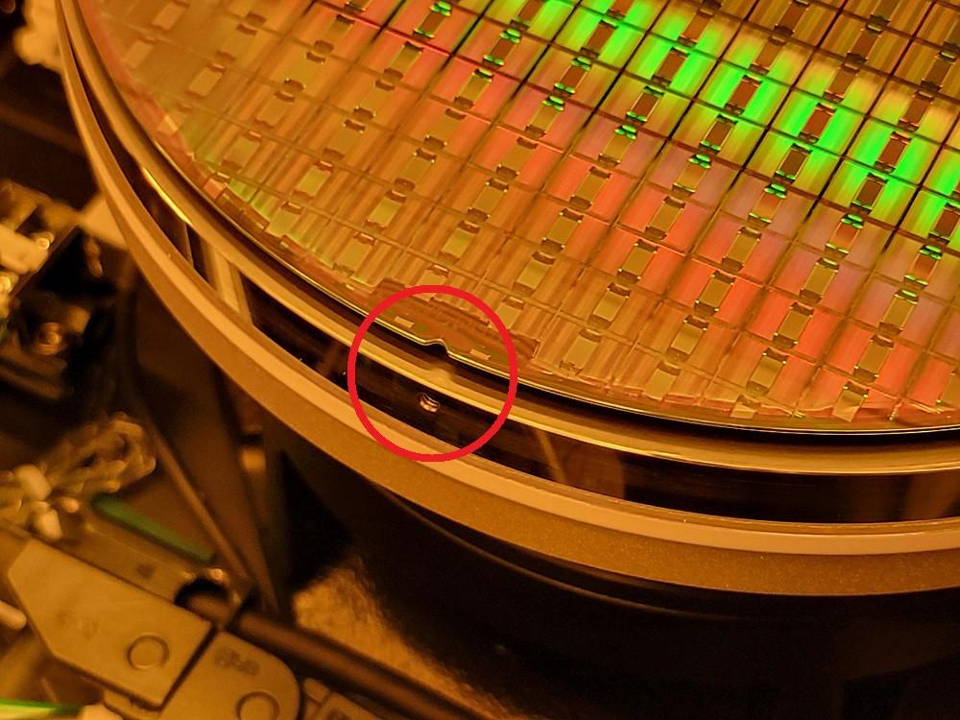
    - Close the Front Access Door.
    - Press “Start” (Figure 8ac).

Figure 8ac: START
Atomica Corp. EOI-
Running Cenfire Version: 1.0

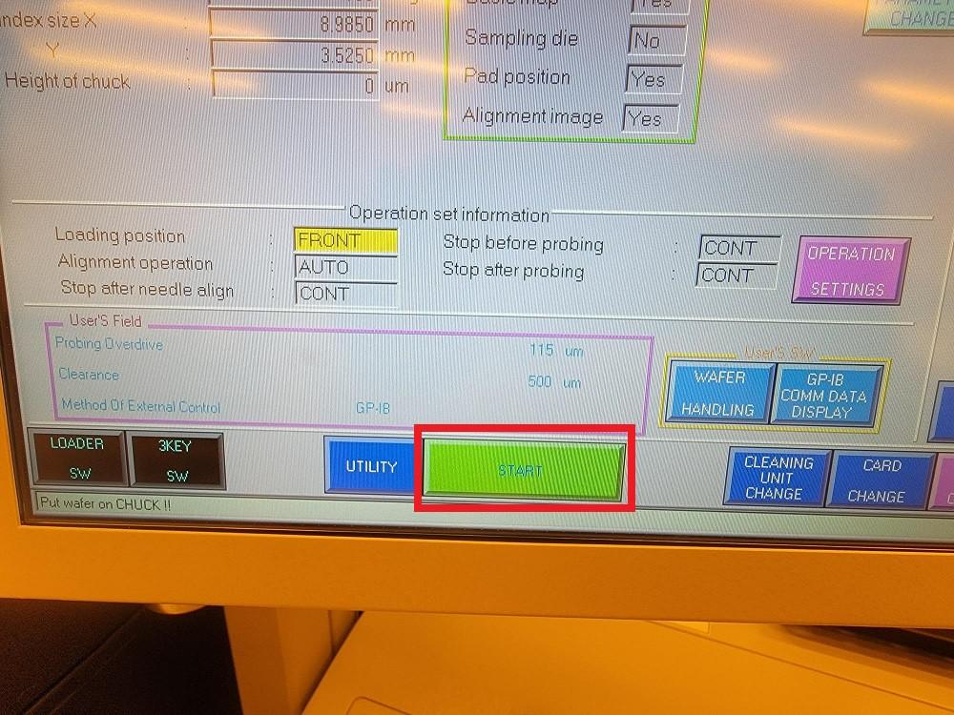
    - Press “Buzzer Release” when prompted with “NEEDLE ALIGNMENT ERROR” (Figure 8ad).

Figure 8ad: Buzzer Release
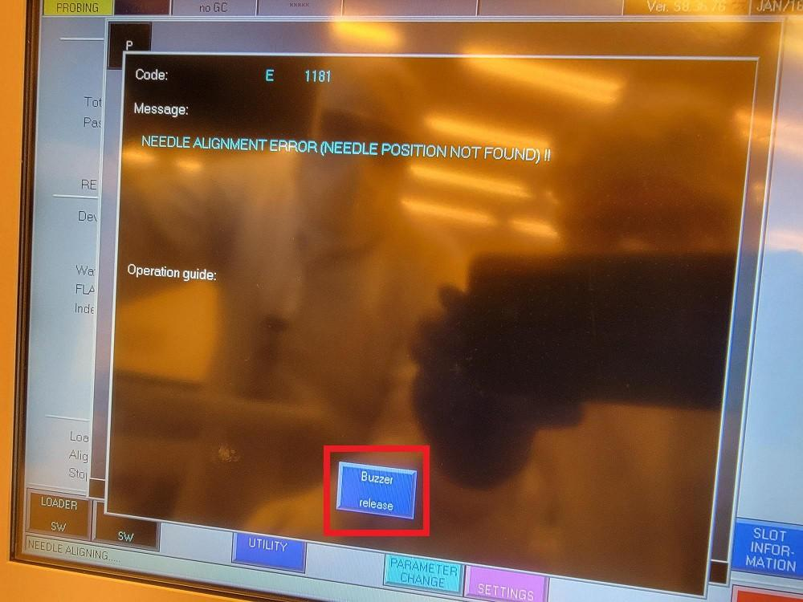
    - Press “Clear screen” when prompted with another “NEEDLE ALIGNMENT ERROR” (Figure 8ae).

Figure 8ae: Clear Screen
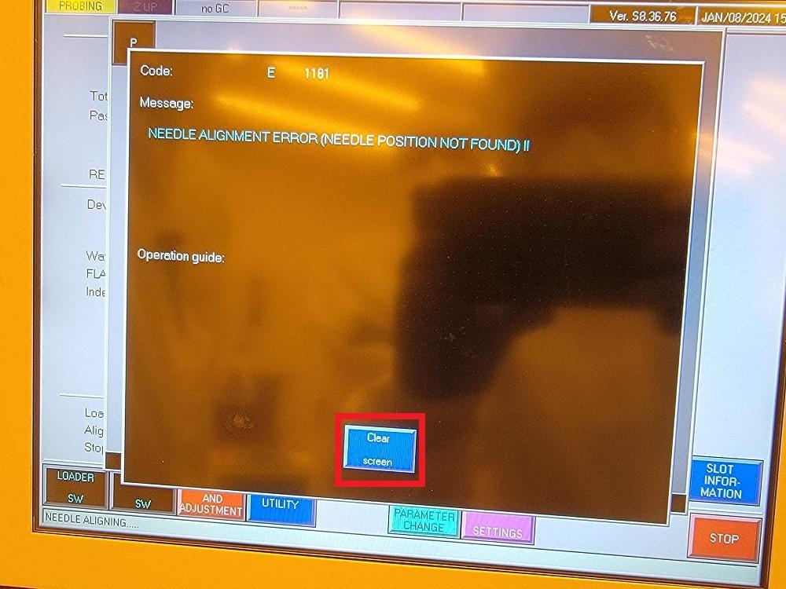
    - Press “Clear screen” when prompted with “Set CROSS MARK on needle position and push <DATA IN>” (Figure 8af).
Atomica Corp. EOI-
Running Cenfire Version: 1.0

Figure 8af: Clear Screen
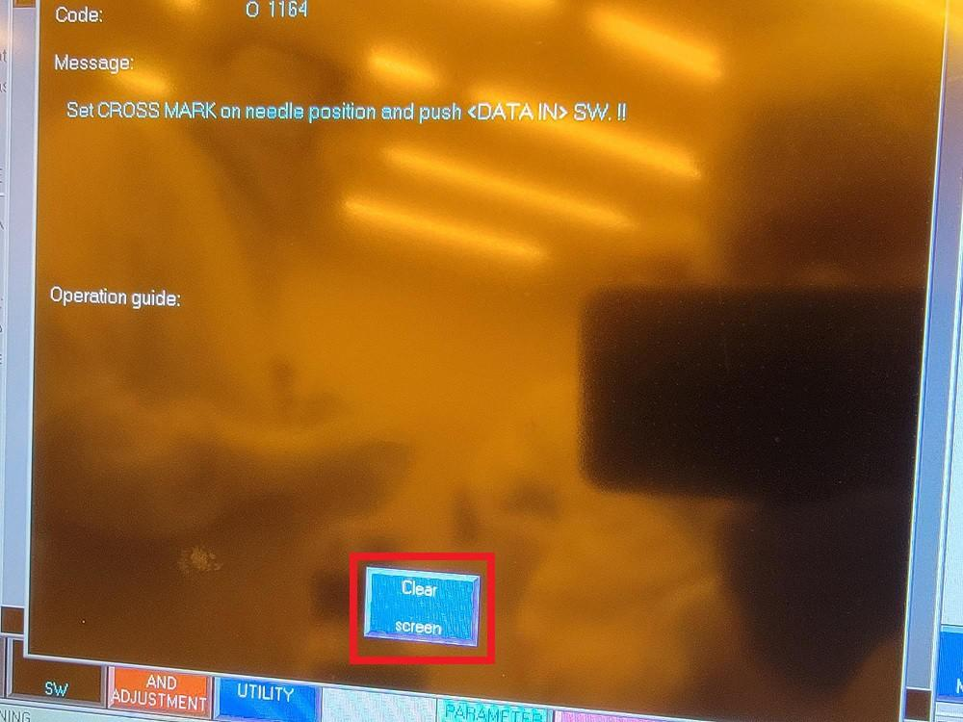
    - Press the directional arrows to jog the chuck so that the tips of the probe needles are aligned with the circles overlaying the camera feed (Figure 8ag).

NOTE: The dark green buttons can be used for fine adjustment.

Figure 8ag: Jog Chuck Until Needles Align with Circles
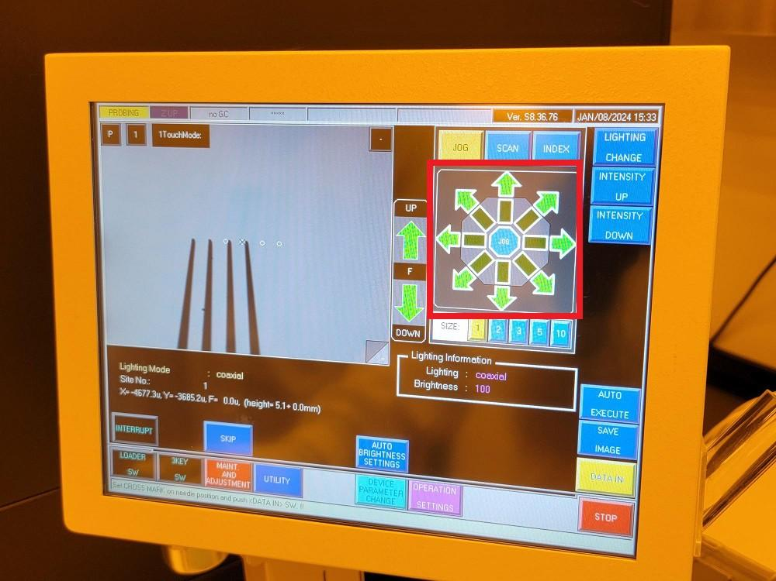
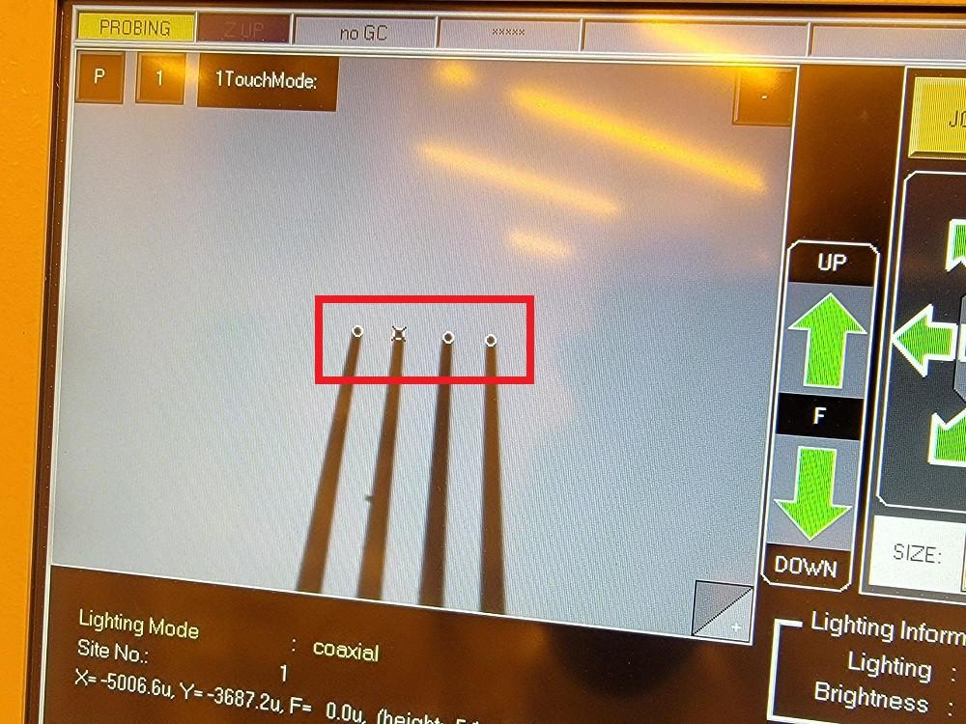

    - Press “DATA IN” (Figure 8ah).
Atomica Corp. EOI-
Running Cenfire Version: 1.0

Figure 8ah: DATA IN
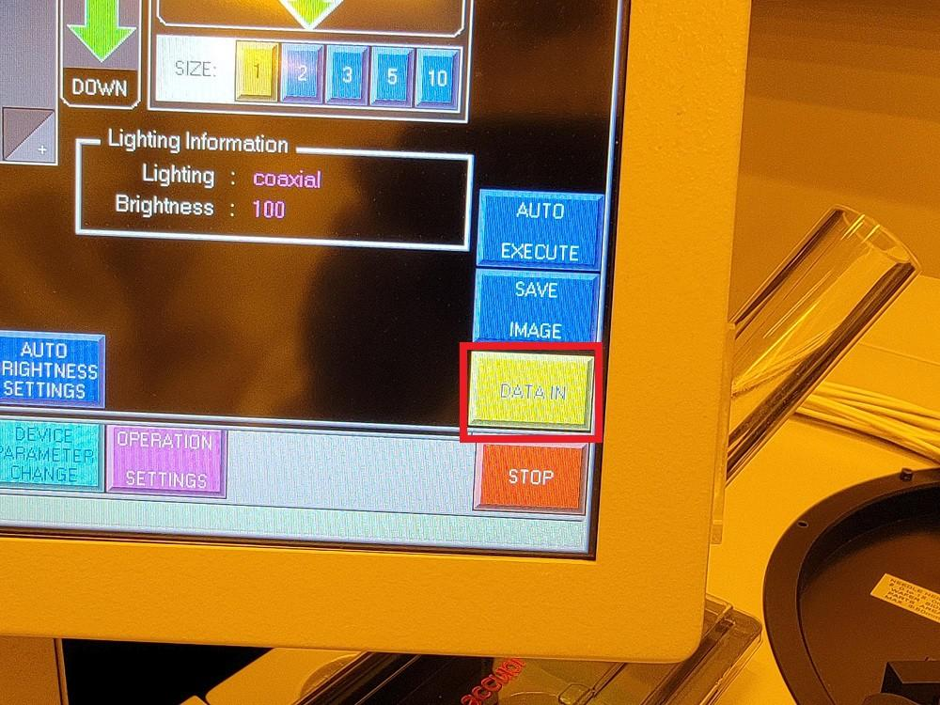
    - Press “Clear screen” when prompted with “STOP AFTER AUTO NEEDLE HEIGHT SETTING DONE” (Figure 8ai).

Figure 8ai: Clear Screen
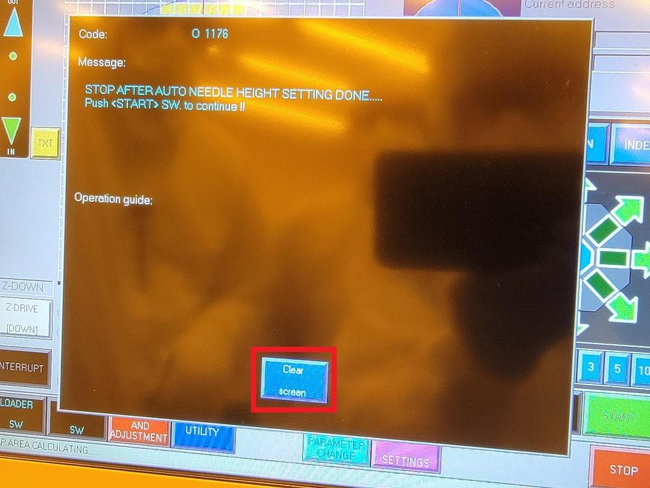
    - Verify the CARD RELATIVE Z HEIGHT and Probing Overdrive (Figure 8aj).

NOTE: These are program specific settings. Contact Test/Metrology Engineer for correct settings.

Figure 8aj: Verify Probe Settings
Atomica Corp. EOI-
Running Cenfire Version: 1.0

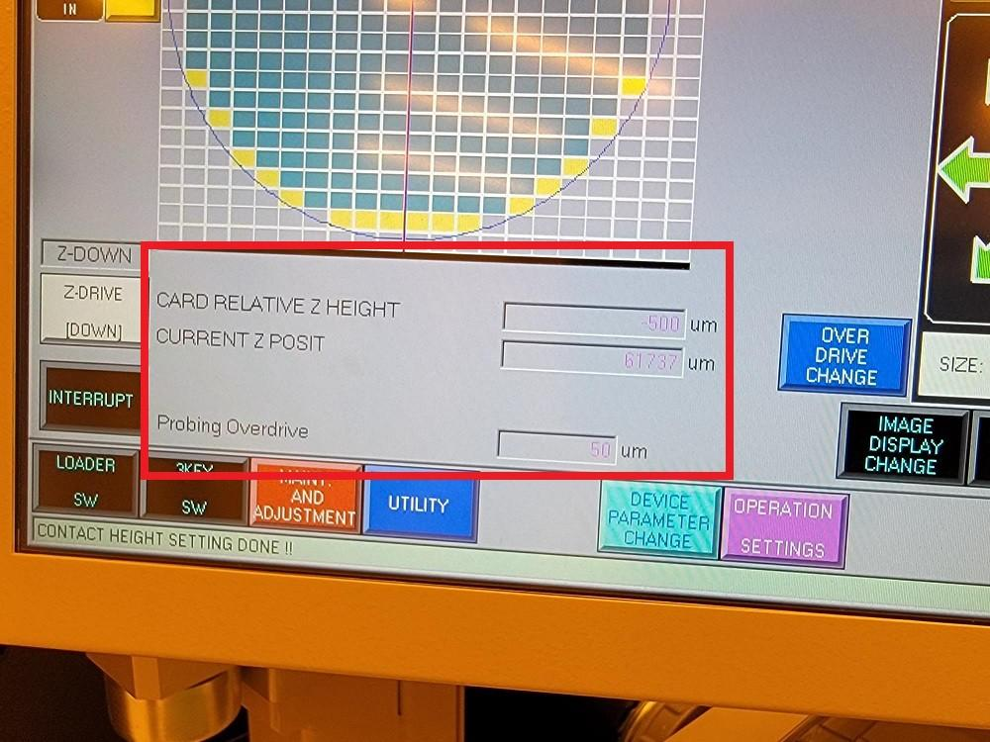
    - Press “START” (Figure 8ak).

Figure 8ak: START
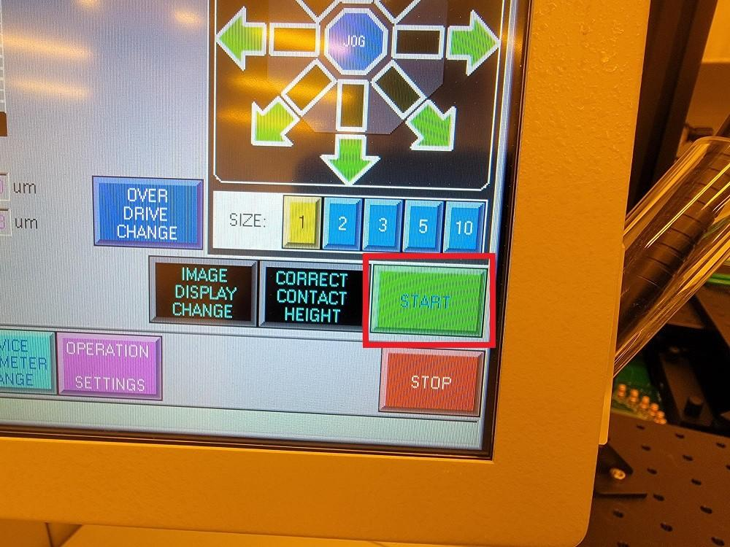
    - “Probing” will be displayed in the bottom left corner of the screen (Figure 8al).

Figure 8al: Ready for Probing
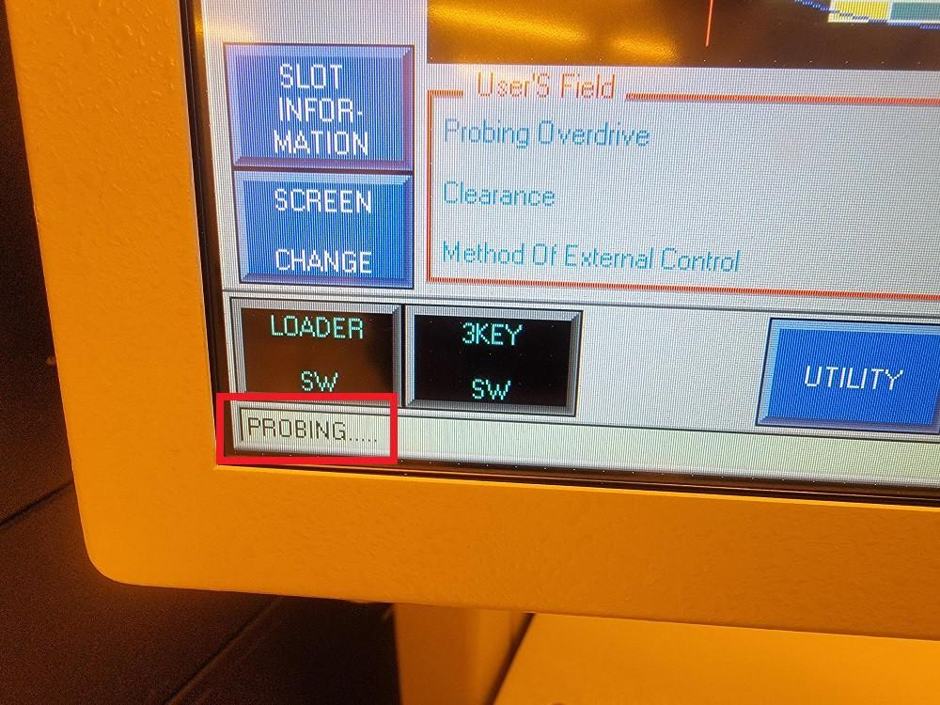
    - Move to the PROBE08 desktop PC and launch the Atomica Tester executable. (Figure 8am).

NOTE: Login to the PC with the following credentials (User: Atomica, Password:
Atomica Corp. EOI-
Running Cenfire Version: 1.0

Engineer2022)

Figure 8am: Shortcuts to Probing Executables at Top Right of Desktop
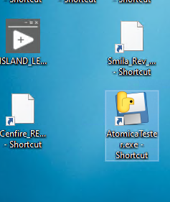

    - Verify instruments are connected, verify working directory is correct. Load the CenfireATA ATA folder. Verify the recipe selected matches the bench actually in use - some Cenfire recipes are bench-tagged and only apply to a specific prober's SMU wiring.

Figure 8an: Load ATA folder
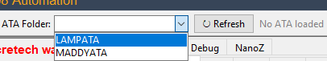

    - Go to recipe tab, check that correct probe card is selected. Check that the recipe is correct for your probe card. (Figure 8ao).

Figure 8ao: Recipe tab, Match the probe card with the label on the physical card.

Atomica Corp. EOI-
Running Cenfire Version: 1.0

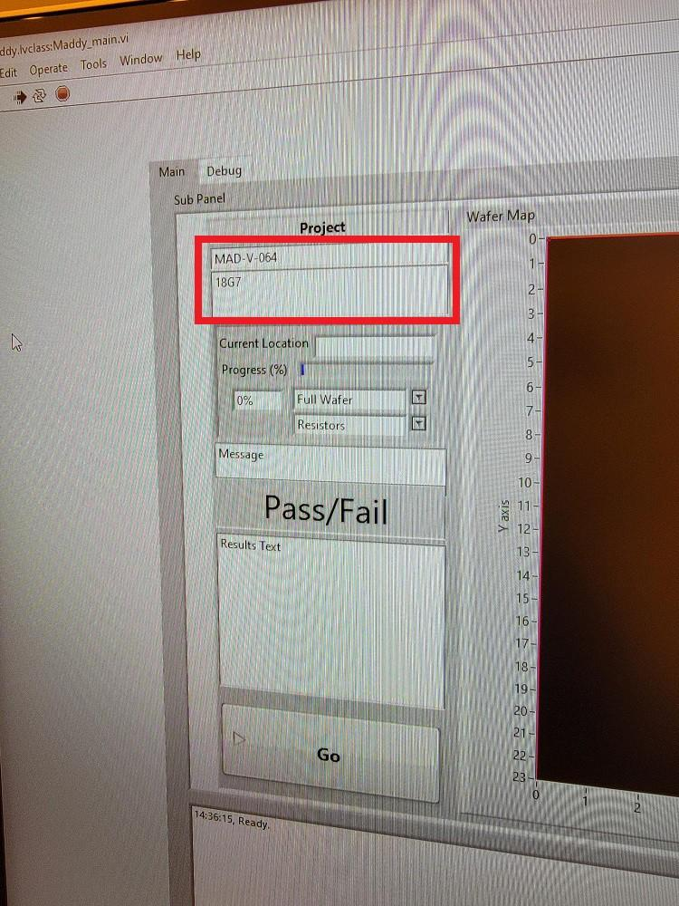
    - Go to the Run tab, load the recipe. Press Full die to test all dies, Press Test die to test only 5 dies or any set of selected ones. Note: The prober will not run and throw an error unless it says “Probing” on the bottom left. (Figure 8ap).

Figure 8ap: Press Full or Test Die to Start Probing Sequence
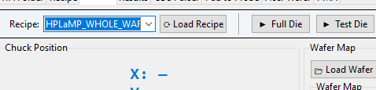
    - Probing commences.
    - Once probing has completed, press “UNLOAD” under the “Run” tab (Figure 8aq).

Figure 8aq: UNLOAD
Atomica Corp. EOI-
Running Cenfire Version: 1.0

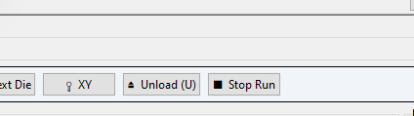
    - Open the Front Access Door and remove the wafer from the chuck.

NOTE: For directions on unloading wafers using CASSETTE, refer to the steps
8.4.13 below.

    - Close the Front Access Door and press “START” on the Accretech UF200R interface (Figure 8ar).

Figure 8ar: START for Removing Wafer
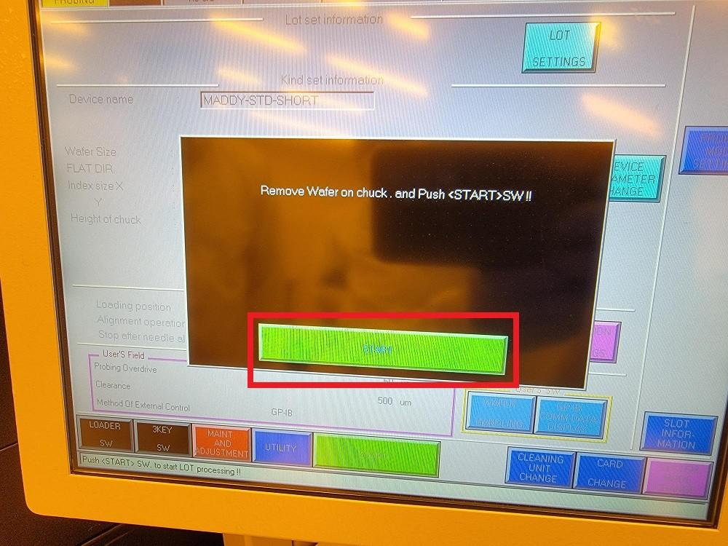
    - Press “Clear screen" when prompted with ”DONE!!" (Figure 8as).

Figure 8as: DONE!!
Atomica Corp. EOI-
Running Cenfire Version: 1.0

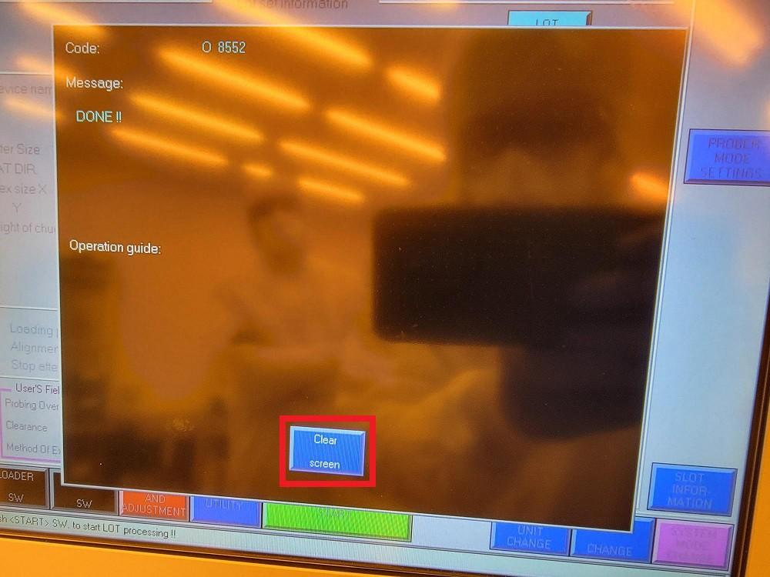

Cassette Loading and Unloading
    - Press “OPERATION SETTINGS” (Figure 8at).

Figure 8at: OPERATION SETTINGS

    - Verify the “CASSETTE” Loading/Unloading position is highlighted and press “ENT” (Figure 8au).

Figure 8au: Verify CASSETTE Loading/Unloading Position
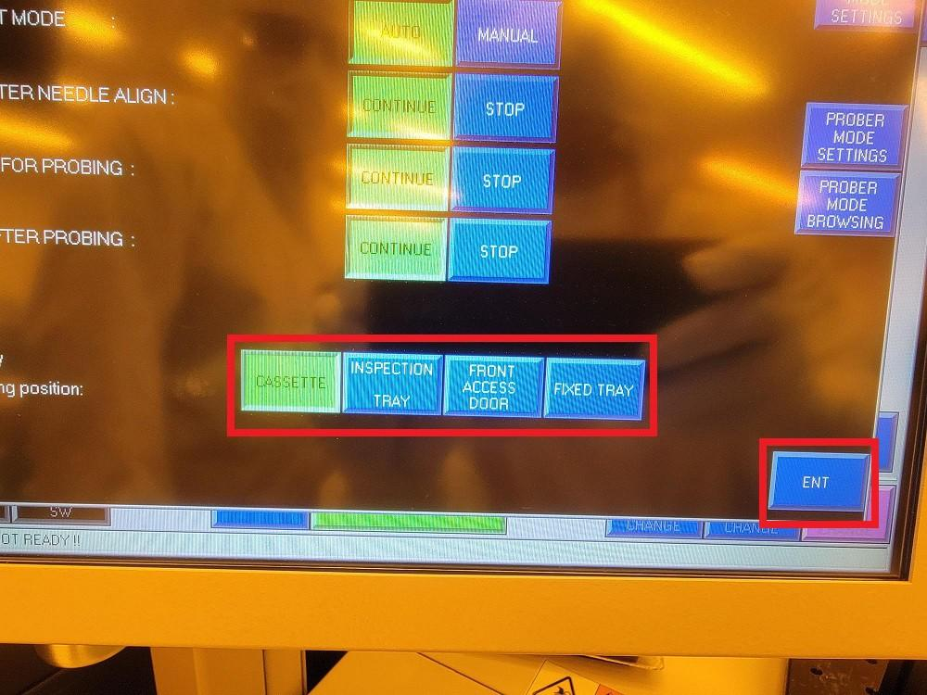
Atomica Corp. EOI-
Running Cenfire Version: 1.0

    - Press “LOADER SW” (Figure 8av).

Figure 8av: LOADER SW
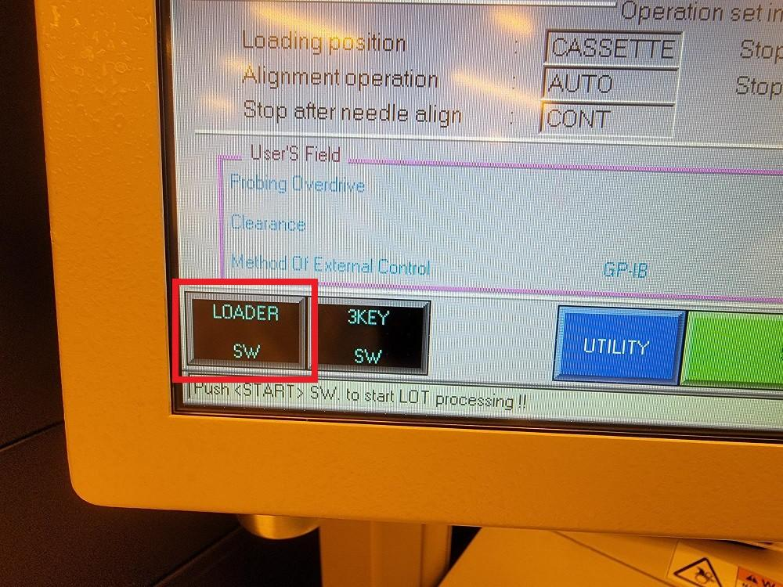
    - Press “TRAY LOCK/UNLK 1” (Figure 8aw).

Figure 8aw: TRAY LOCK/UNLK 1
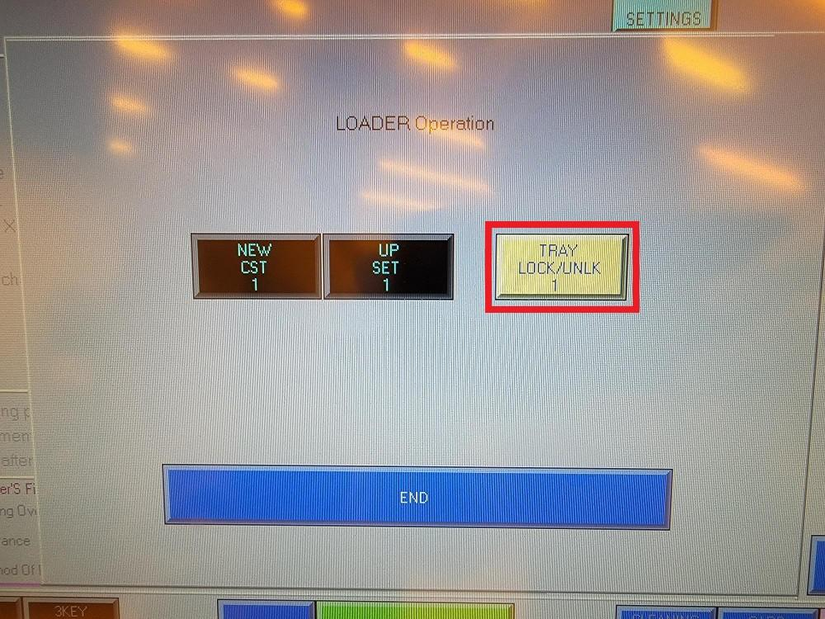
    - Open the cassette tray (Figure 8ax).

Figure 8ax: Open Cassette Tray
Atomica Corp. EOI-
Running Cenfire Version: 1.0

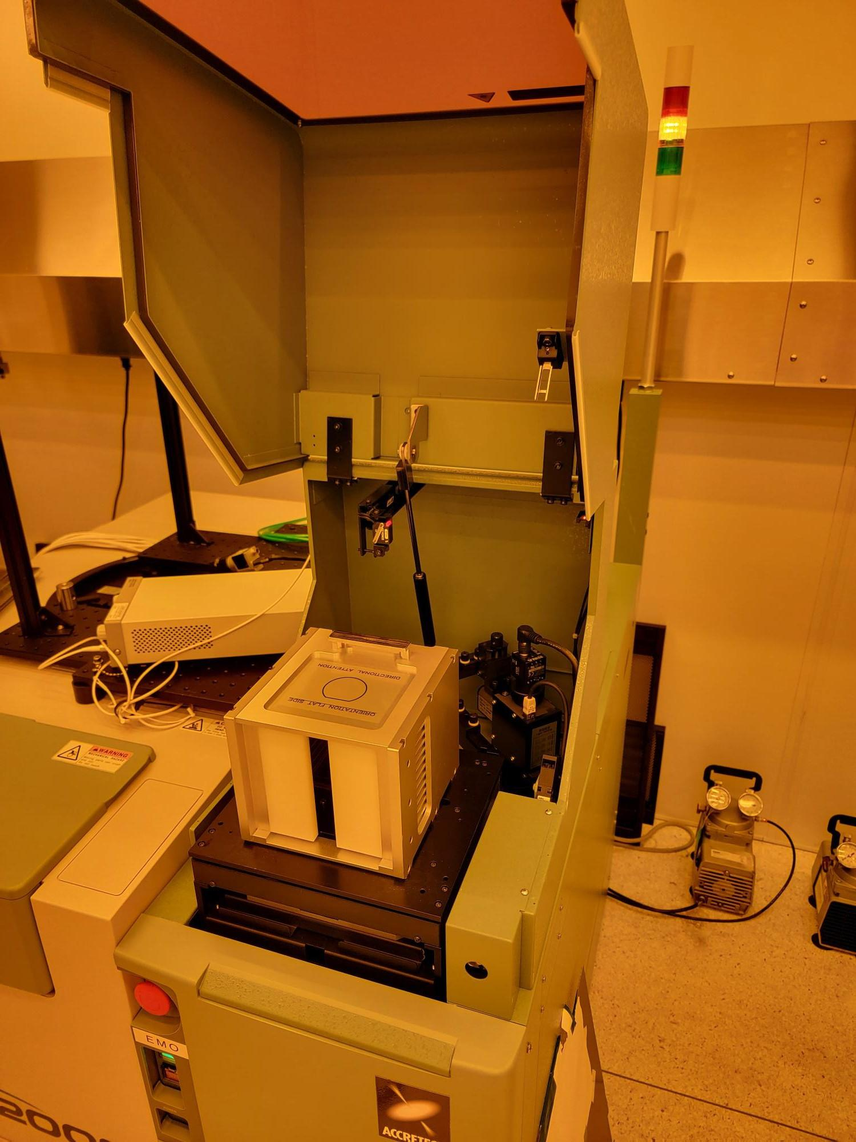

    - Remove the PROBE08 cassette and load wafers into consecutive slots starting from the slot closest to the H-bar. Load wafers so that the sides to be probed are facing away from the H-bar (Figure 8ay).

Figure 8ay: Wafer Loaded into Slot Closest to H-bar
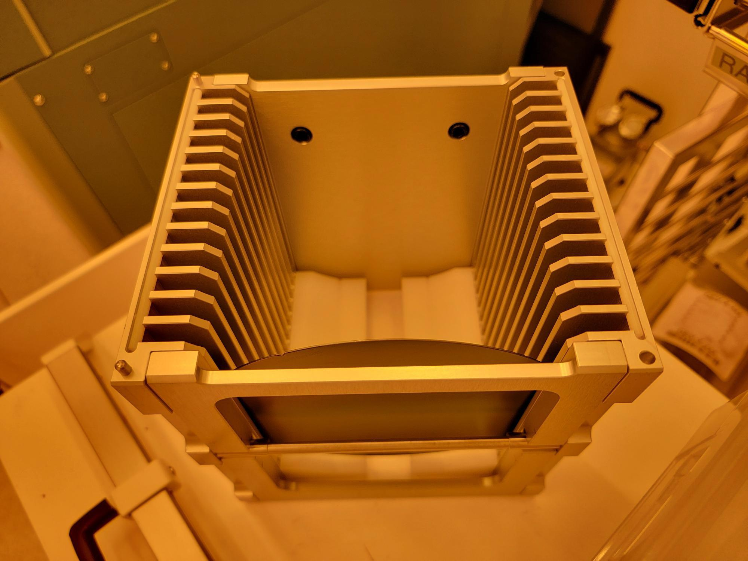
    - Load the PROBE08 cassette into the cassette tray so that the H-bar is facing down and fits within the groove (Figure 8az).

Figure 8az: Cassette Loaded into Tray
Atomica Corp. EOI-
Running Cenfire Version: 1.0

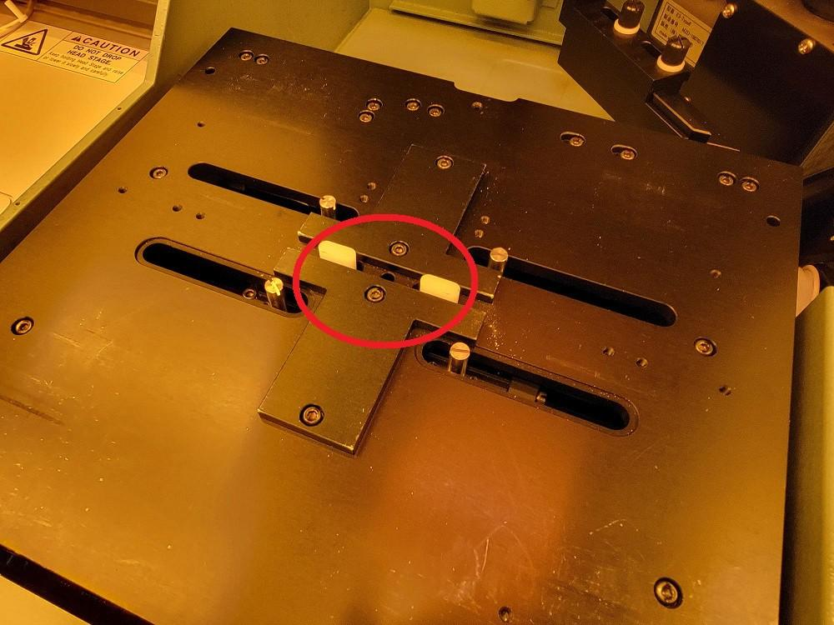
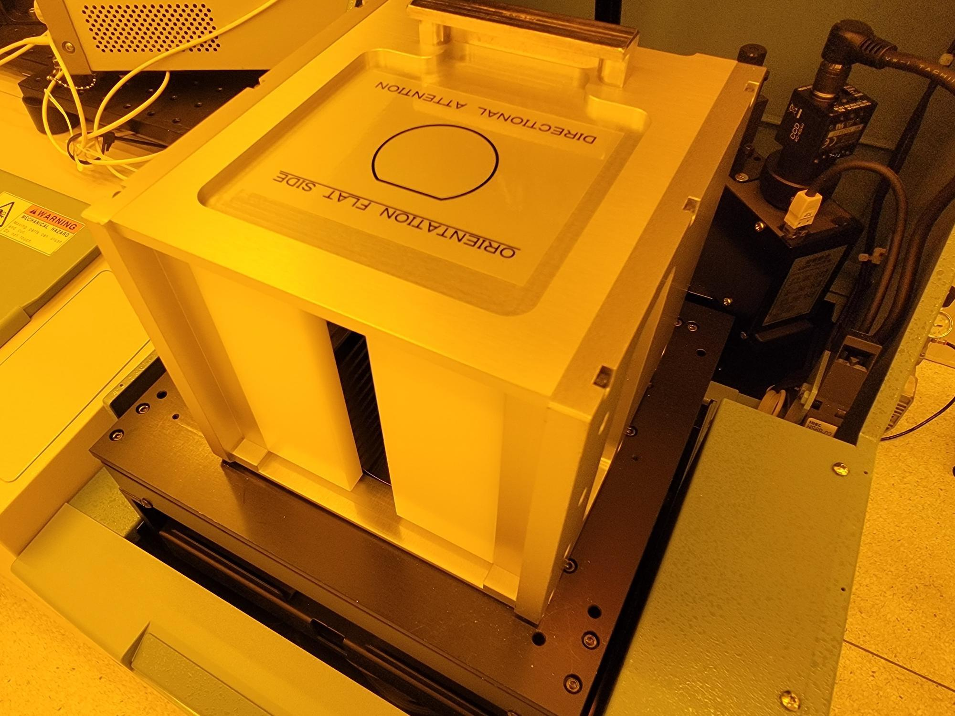

    - Close the cassette tray.
    - Press “TRAY LOCK/UNLK 1” (Figure 8ba).

Figure 8ba: TRAY LOCK/UNLK 1
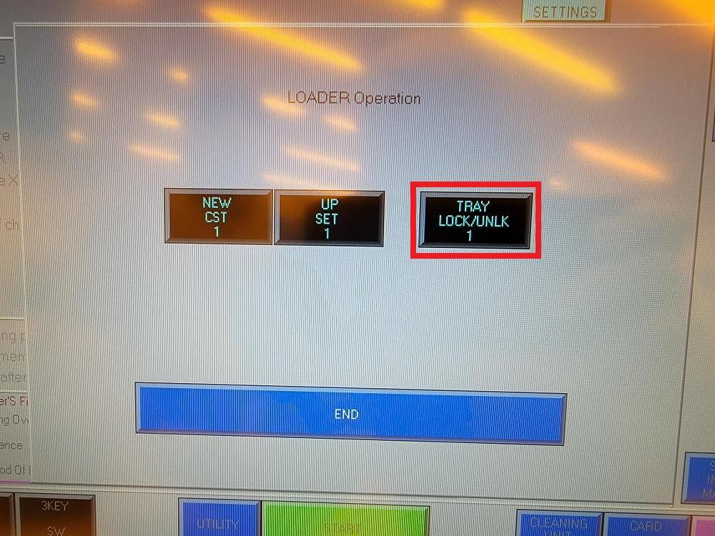
    - Press “NEW CST 1” (Figure 8bb).

Figure 8bb: NEW CST 1
Atomica Corp. EOI-
Running Cenfire Version: 1.0

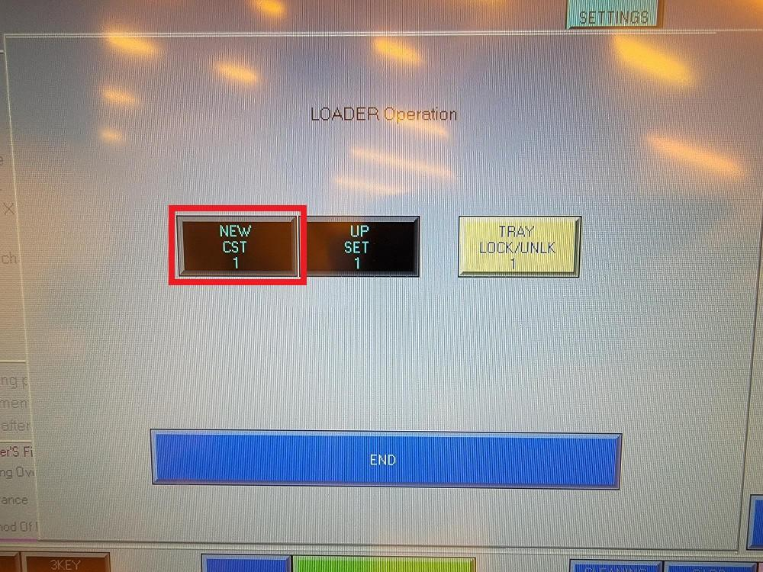
    - The cassette will lower into the tool and a wafer will be loaded.
    - Proceed with probing by following the Starting Probe Routine steps above, from the point after the wafer is loaded and aligned.
    - After probing is completed, press “Clear screen” when prompted with “DONE !!” (Figure 8bc).

Figure 8bc: Clear Screen
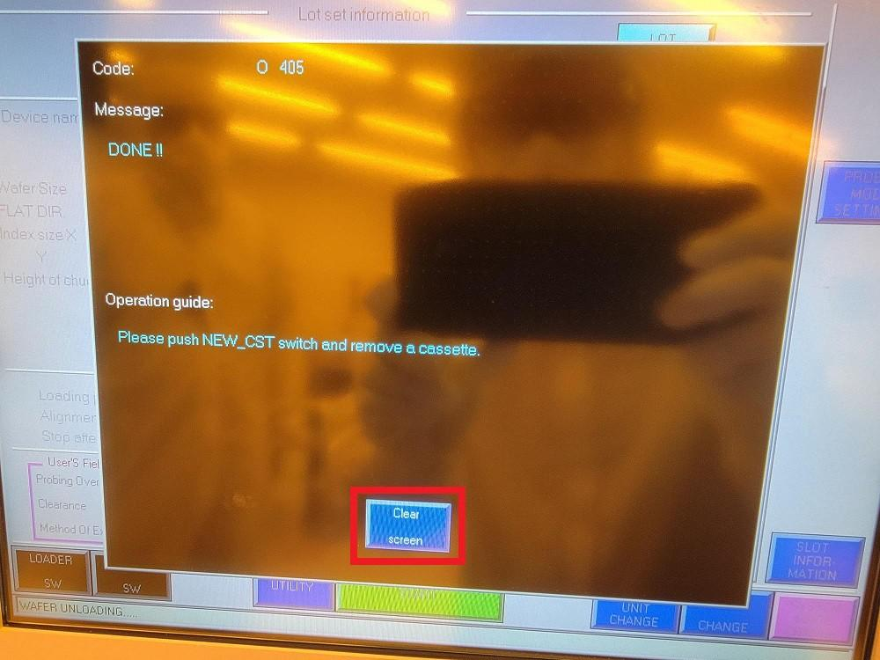
    - Press “NEW CST 1” (Figure 8bd).

Figure 8bd: NEW CST 1

Atomica Corp. EOI-
Running Cenfire Version: 1.0

    - Press “LOADER SW” (Figure 8be).

Figure 8be: LOADER SW

    - Press “TRAY LOCK/UNLK 1” (Figure 8bf).

Figure 8bf: TRAY LOCK/UNLK 1

    - Open the cassette tray and remove the wafers. Close the cassette tray with the empty PROBE08 cassette loaded inside (Figure 8bg).

Figure 8bg: Leave Cassette Inside Tray
Atomica Corp. EOI-
Running Cenfire Version: 1.0

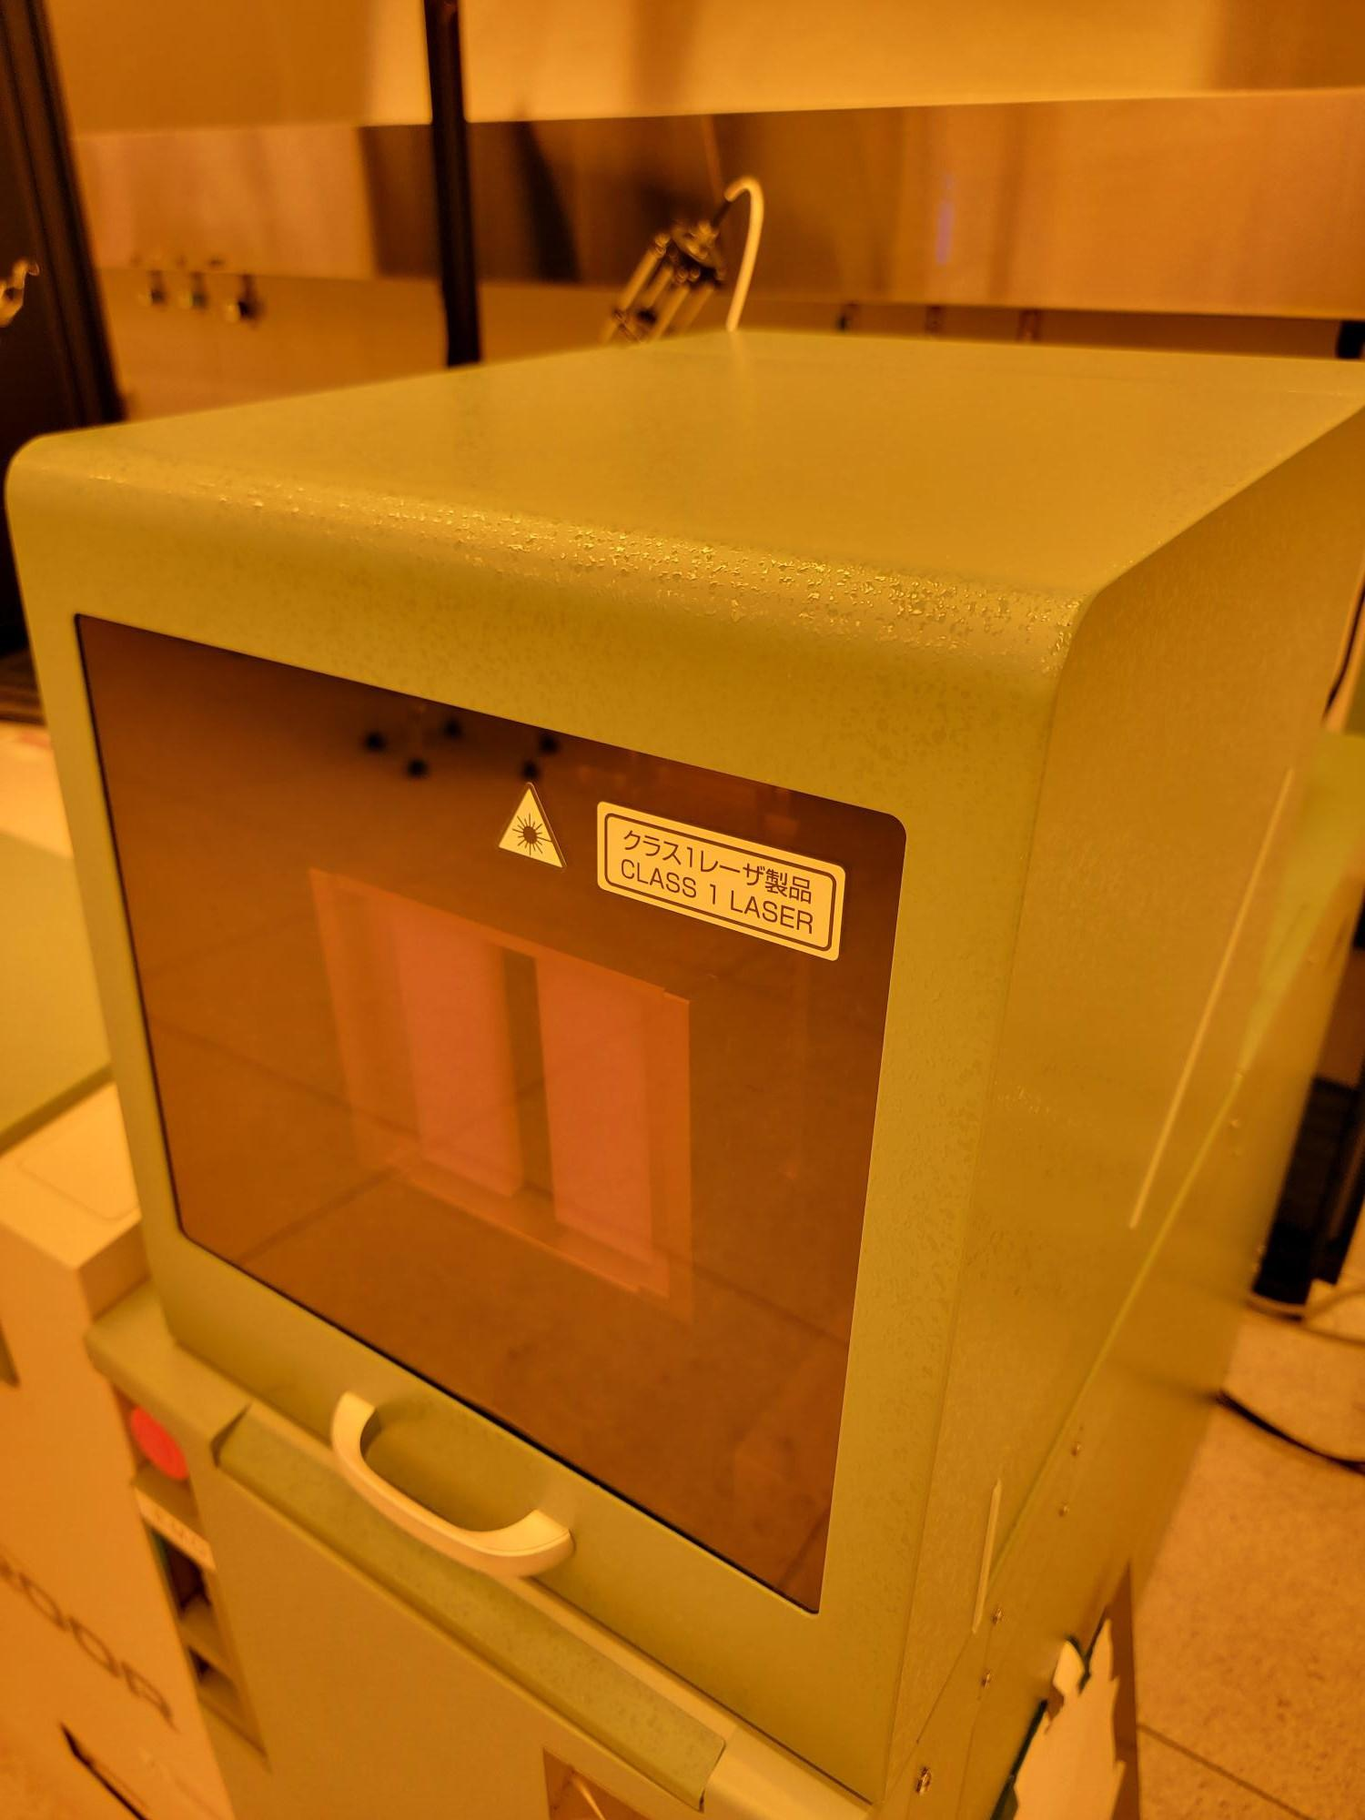

    - Press “TRAY LOCK/UNLK 1” (Figure 8bh).

Figure 8bh: TRAY LOCK/UNLK 1

    - Press “END” (Figure 8bi).

Figure 8bi: END
Atomica Corp. EOI-
Running Cenfire Version: 1.0

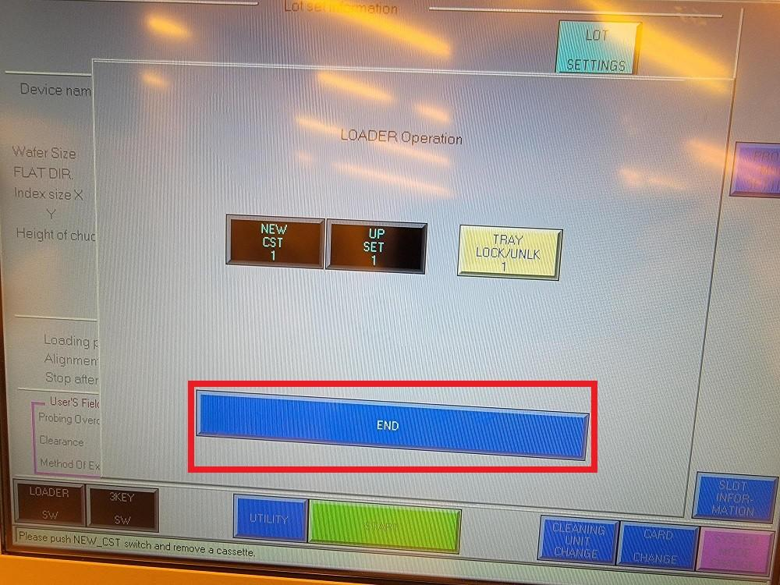

Qualiﬁcation Procedure

Records
\\prober\ETL\RAWDATA\PROBE08 (or the applicable export path for this bench/project)

Attachments
(none)

